

**Department of Information Technology**

# **CERTIFICATE**

This is to certify that **Gaurang A Raorane** of**D15A**semester**VI,**have successfully completed necessary experiments in the **MAD & PWA Lab** under my supervision in **VES** **Institute of Technology** during the academic year **2023-2024.**

Lab Assistant Subject Teacher

**Mrs. Kajal Joseph**

Principal Head of Department

**Dr. Mrs. Shalu Chopra**

**Name of the Course :** MAD & PWA Lab **Course Code :** ITL604

**Year/Sem/Class :** D15A/D15B **A.Y.:** 23-24

**Faculty Incharge** : Mrs. Kajal Joseph.

**Lab Teachers :** Mrs. Kajal Jewani.

**Email :** [kajal.jewani@ves.ac.in](mailto:kajal.jewani@ves.ac.in)

**Programme Outcomes**: The graduate will be able to:

PO1) Basic Engineering knowledge: An ability to apply the fundamental knowledge in mathematics, science and engineering to solve problems in Computer engineering.

PO2) Problem Analysis: Identify, formulate, research literature and analyze computer engineering problems reaching substantiated conclusions using first principles of mathematics, natural sciences and computer engineering and sciences.

PO3) Design/ Development of Solutions: Design solutions for complex computer engineering problems and design system components or processes that meet specified needs with appropriate consideration for public health and safety, cultural, societal and environmental considerations.

PO4) Conduct investigations of complex engineering problems using research-based knowledge and research methods including design of experiments, analysis and interpretation of data and synthesis of information to provide valid conclusions.

PO5) Modern Tool Usage: Create, select and apply appropriate techniques, resources and modern computer engineering and IT tools including prediction and modeling to complex engineering activities with an understanding of the limitations.

PO6) The Engineer and Society: Apply reasoning informed by contextual knowledge to assess societal, health, safety, legal and cultural issues and the consequent responsibilities relevant to computer engineering practice.

PO7) Environment and Sustainability: Understand the impact of professional computer engineering solutions in societal and environmental contexts and demonstrate knowledge of and need for sustainable development.

PO8) Ethics: Apply ethical principles and commit to professional ethics and responsibilities and norms of computer engineering practice.

PO9) Individual and Team Work: Function effectively as an individual, and as a member or leader in diverse teams and in multidisciplinary settings.

PO10) Communication: Communicate effectively on complex engineering activities with the engineering community and with society at large, such as being able to comprehend and write effective reports and design documentation, make effective presentations and give and receive clear instructions.

PO11) Project Management and Finance: Demonstrate knowledge and understanding of computer engineering and management principles and apply these to one's own work, as a member and leader in a team, to manage projects and in multidisciplinary environments.

PO12) Life-long Learning: Recognize the need for and have the preparation and ability to engage in independent and lifelong learning in the broadest context of technological change.

**Program specific Outcomes**

**PSO1)** An ability to manage and analyze data / information effectively for making better decisions.

**PSO2)** Demonstrate the ability to use state of the art technologies and tools including Free and Open Source Software (FOSS) tools in developing software.

**Lab Objectives:**

| **Sr. No.** | **Lab Objectives** |
| --- | --- |
| **The Lab experiments aims:** | |
| **1** | Learn the basics of the Flutter framework. |
| **2** | Develop the App UI by incorporating widgets, layouts, gestures and animation |
| **3** | Create a production ready Flutter App by including files and firebase backend service. |
| **4** | Learn the Essential technologies, and Concepts of PWAs to get started as quickly and efficiently as possible |
| **5** | Develop responsive web applications by combining AJAX development techniques with the jQuery JavaScript library. |
| **6** | Understand how service workers operate and also learn to Test and Deploy PWA. |

**Lab Outcomes:**

| **Sr. No.** | | **Lab Outcomes** | **Cognitive levels of attainment as per Bloom’s Taxonomy** |
| --- | --- | --- | --- |
| **On Completion of the course the learner/student should be able to:** | | | |
| **1** | Understand cross platform mobile application development using Flutter framework | | L1, L2 |
| **2** | Design and Develop interactive Flutter App by using widgets, layouts, gestures and animation | | L3 |
| **3** | Analyze and Build production ready Flutter App by incorporating backend services and deploying on Android / iOS | | L3, L4 |
| **4** | Understand various PWA frameworks and their requirements | | L1, L2 |
| **5** | Design and Develop a responsive User Interface by applying PWA Design techniques | | L3 |
| **6** | Develop and Analyse PWA Features and deploy it over app hosting solutions | | L3, L4 |

**Index**

| **Sr.No** | **Experiment Title** | **LO** | **DOP** | **DOS** | **Grade** |
| --- | --- | --- | --- | --- | --- |
| **1.** | To install and configure the Flutter Environment | LO1 | 19/01 | 26/01 | 15 |
| **2.** | To design Flutter UI by including common widgets. | LO2 | 26/01 | 02/02 | 15 |
| **3.** | To include icons, images, fonts in Flutter app | LO2 | 02/02 | 09/02 | 15 |
| **4.** | To create an interactive Form using form widget | LO2 | 09/02 | 16/02 | 15 |
| **5.** | To apply navigation, routing and gestures in Flutter App | LO2 | 16/02 | 23/02 | 15 |
| **6.** | To Connect Flutter UI with fireBase database | LO3 | 23/02 | 08/03 | 15 |
| **7.** | To write meta data of your Ecommerce PWA in a Web app manifest file to enable “add to homescreen feature”. | LO4 | 08/03 | 15/03 | 15 |
| **8.** | To code and register a service worker, and complete the install and activation process for a new service worker for the E-commerce PWA | LO5 | 15/03 | 22/03 | 15 |
| **9.** | To implement Service worker events like fetch, sync and push for E-commerce PWA | LO5 | 22/03 | 31/03 | 15 |
| **10.** | To study and implement deployment of Ecommerce PWA to GitHub Pages. | LO5 | 29/03 | 31/03 | 15 |
| **11.** | To use google Lighthouse PWA Analysis Tool to test the PWA functioning. | LO6 | 29/03 | 31/03 | 15 |
| **12.** | Assignment-1 | LO1,LO2,LO3 | 28/01 | 05/02 | 5 |
| **13.** | Assignment-2 | LO4,LO5,LO6 | 14/03 | 21/03 | 4 |

MAD & PWA Lab

Journal

| Experiment No. | 01 |
| --- | --- |
| Experiment Title. | To install and configure the Flutter Environment |
| Roll No. | 49 |
| Name | Gaurang A Roarane |
| Class | D15A |
| Subject | MAD & PWA Lab |
| Lab Outcome | LO1: Understand cross platform mobile application development using Flutter framework |
| Grade: | 15 |

Experiment - 1

**Aim -** Installation and Configuration of Flutter Environment.

**Pre Requisites**: Android Studio Hedgehog, Visual Studio Code and Flutter package.I highly recommend watching this video, for Setting up your Flutter Environment and your Virtual Device: https://youtu.be/ZSWfgxrxN0M?feature=shared

**Installation -**

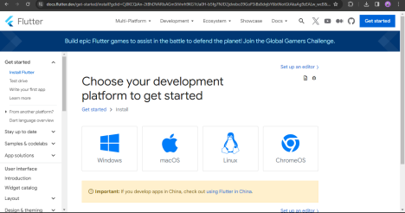

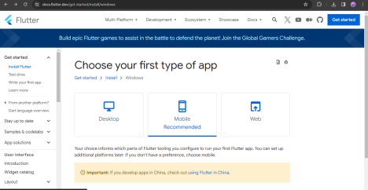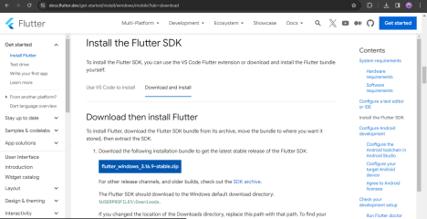Extract the files in the directory -

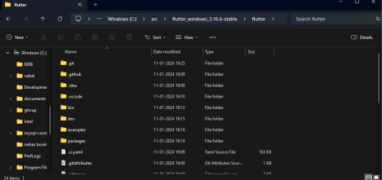Setup path in Environment variables -

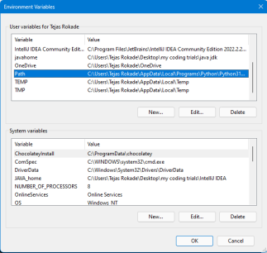

Create new variable and insert the path to bin folder and apply -

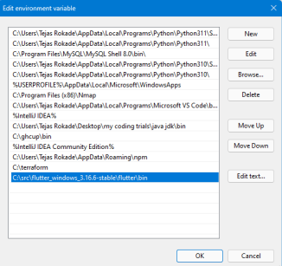

Then on CMD -

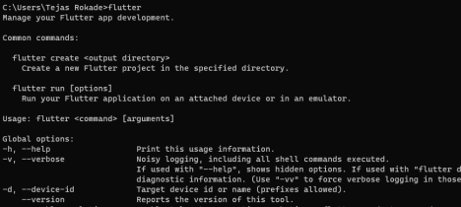

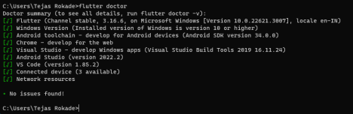The error for Android toolchain will occur if havent installed android SDK Command Line Tools in Android Studios SDK Tools.

And IF issue of android licenses occurs run Flutter –android-licenses command in the prompt and type y+enter till process is complete

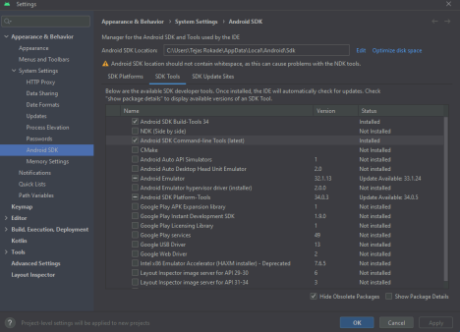

**Code -**

import 'package:flutter/material.dart';

void main() {

runApp(const MyApp());

}

class MyApp extends StatelessWidget {

const MyApp({Key? key}) : super(key: key);

@override

Widget build(BuildContext context) {

return MaterialApp(

title: 'Welcome to Flutter',

home: Scaffold(

appBar: AppBar(

title: const Text('Welcome to Flutter'),

),

body: const Center(

child: Text('Hello Tejas’'),

),

),

);

}

}

**Output -**

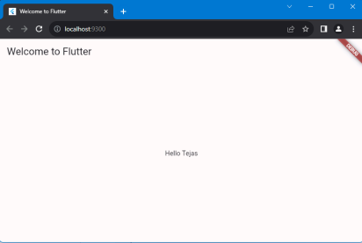

MAD & PWA Lab

Journal

| Experiment No. | 02 |
| --- | --- |
| Experiment Title. | To design Flutter UI by including common widgets. |
| Roll No. | 49 |
| Name | Gaurang A Roarane |
| Class | D15A |
| Subject | MAD & PWA Lab |
| Lab Outcome | LO2: Design and Develop interactive Flutter App by using widgets, layouts, gestures and animation |
| Grade: | 15 |

**Experiment - 2**

**Aim :-** To design Flutter UI by including common widgets.

Theory :-

In Flutter, widgets are the basic building blocks for creating user interfaces. They represent the visual elements in the UI, such as buttons, text fields, and containers. Here's a theoretical overview of some common Flutter widgets that you might encounter in a laboratory (lab) setting:

* **Container Widget:**
  + Theory: The Container widget is a versatile and powerful widget that can contain other widgets. It allows customization of dimensions, padding, margin, decoration, and more.
  + Lab Use: Use Container to structure and style the layout of your lab interface. Adjust its properties to control spacing and alignment.
* **Text Widget:**
  + Theory: The Text widget displays a string of text with various styling options. It is used to present information to the user.
  + Lab Use: Utilize Text to display important information, labels, or instructions within your lab app.
* **Row and Column Widgets:**
  + Theory: Row and Column are layout widgets that allow you to arrange child widgets in a horizontal (row) or vertical (column) sequence.
  + Lab Use: Organize and structure your UI elements in a row or column format for better readability and organization.
* **ListView Widget:**
  + Theory: ListView is a scrollable list of widgets. It is used to display a scrolling, linear list of widgets.
  + Lab Use: Implement ListView to display a list of items, such as experiment steps, results, or any dynamic data.
* **AppBar Widget:**
  + Theory: The AppBar widget provides a top app bar with options for navigation, title, and actions.
  + Lab Use: Include an AppBar to give your lab app a consistent and recognizable navigation structure.
* **Form and TextFormField Widgets:**
  + Theory: Form and TextFormField are used for creating forms and handling user input.
  + Lab Use: Implement a form structure using Form and capture user input with TextFormField for data entry and interaction.
* **Button Widgets (ElevatedButton, TextButton, and OutlinedButton):**
  + Theory: Flutter provides various button widgets, each with its visual style and behavior.
  + Lab Use: Use buttons like ElevatedButton, TextButton, and OutlinedButton for actions such as submitting data, navigating, or triggering experiments.
* **Image Widget:**
  + Theory: The Image widget displays an image from various sources, such as assets or the internet.
  + Lab Use: Use the Image widget to show diagrams, graphs, or other visual content in your lab app.
* **AlertDialog and SnackBar Widgets:**
  + Theory: AlertDialog and SnackBar are used for displaying pop-up messages to the user.
  + Lab Use: Provide important notifications, alerts, or feedback to users through these pop-up widgets.
* **Scaffold Widget:**
  + Theory: Scaffold is a basic skeletal structure that contains the visual elements of a material design app.
  + Lab Use: Use Scaffold as the overall structure of your lab app, providing a consistent layout with an app bar, body, and other elements.

Input :-

import 'package:firebase_core/firebase_core.dart';

import 'package:flutter/material.dart';

import 'package:osiris/Services/auth.dart';

import 'package:osiris/routes.dart';

import 'package:provider/provider.dart';

void main() async {

WidgetsFlutterBinding.ensureInitialized();

await Firebase.initializeApp();

runApp(const App());

}

class App extends StatefulWidget {

const App({super.key});

@override

State<App> createState() => _AppState();

}

class _AppState extends State<App> {

@override

Widget build(BuildContext context) {

return ChangeNotifierProvider(

create: (context) => GoogleSignInProvider(),

child: MaterialApp.router(

debugShowCheckedModeBanner: false,

routerConfig: router,

),

);

}

}

**MainScreen.dart**  
import 'package:flutter/material.dart';

import 'package:flutter/rendering.dart';

import 'package:osiris/Models/PopularMovies.dart';

import 'package:osiris/Models/TvShow.dart';

import 'package:osiris/Services/API.dart';

import 'package:osiris/Services/consts.dart';

import 'package:osiris/Widgets/BottomNavBar.dart';

import 'package:osiris/Widgets/CarouselCard.dart';

import 'package:osiris/Widgets/CustomLists.dart';

import 'package:osiris/Widgets/LoadingScreen.dart';

import 'package:osiris/Widgets/SectionText.dart';

class MainScreen extends StatefulWidget {

const MainScreen({super.key});

@override

State<MainScreen> createState() => _MainScreenState();

}

class _MainScreenState extends State<MainScreen> {

ScrollController _scrollController = ScrollController();

bool isVisible = true;

late List<Results> popularMovie;

late List<Results> topRatedMovie;

late List<Results> nowPLayingMovie;

late List<TvShow> popularShows;

late List<TvShow> topRatedShows;

bool isLoading = true;

@override

void initState() {

super.initState();

fetchData();

_scrollController = ScrollController();

_scrollController.addListener(listen);

}

@override

void dispose() {

_scrollController.removeListener(listen);

_scrollController.dispose();

super.dispose();

}

void listen() {

final direction = _scrollController.position.userScrollDirection;

if (direction == ScrollDirection.forward) {

show();

} else if (direction == ScrollDirection.reverse) {

hide();

}

}

void show() {

if (!isVisible) {

(setState(

() => isVisible = true,

));

}

}

void hide() {

if (isVisible) {

(setState(

() => isVisible = false,

));

}

}

Future<void> fetchData() async {

topRatedShows = await APIService().getTopRatedShow();

popularMovie = await APIService().getPopularMovie();

topRatedMovie = await APIService().getTopRatedMovie();

popularShows = await APIService().getRecommendedTvShows("1396");

nowPLayingMovie = await APIService().getNowPLayingMovie();

setState(() {

isLoading = false;

});

}

@override

Widget build(BuildContext context) {

var size = MediaQuery.of(context).size;

return Scaffold(

bottomNavigationBar: AnimatedBuilder(

animation: _scrollController,

builder: ((context, child) {

return AnimatedContainer(

duration: const Duration(milliseconds: 800),

curve: Curves.fastLinearToSlowEaseIn,

height: isVisible ? 75 : 0,

child: BottomNavBar(

currentIndex: 0,

),

);

})),

extendBody: true,

body: isLoading

? const LoadingScreen()

: Container(

height: size.height,

width: size.width,

color: background_primary,

child: ListView(

padding: EdgeInsets.zero,

scrollDirection: Axis.vertical,

physics: const BouncingScrollPhysics(),

controller: _scrollController,

shrinkWrap: true,

children: [

CustomCarouselSlider(topRatedShows),

SectionText("Popular", "Movies"),

CustomListMovie(popularMovie),

SectionText("TOP Rated", "Movies"),

CustomListMovie(topRatedMovie),

SectionText("Popular", "Shows"),

CustomListTV(popularShows),

SectionText("NoW PLAying", "Movies"),

CustomListMovie(nowPLayingMovie),

],

),

),

);

}

}

**CarouselCard.dart**  
import 'package:cached_network_image/cached_network_image.dart';

import 'package:flutter/material.dart';

import 'package:flutter/services.dart';

import 'package:go_router/go_router.dart';

import 'package:osiris/Models/TvShow.dart';

import 'package:osiris/Widgets/LandingCard.dart';

class CustomCarouselSlider extends StatelessWidget {

CustomCarouselSlider(this.data, {super.key});

List<TvShow> data;

@override

Widget build(BuildContext context) {

var size = MediaQuery.of(context).size;

return SizedBox(

width: size.width,

height: (size.height * 0.33 < 300) ? 300 : size.height * 0.33,

child: PageView.builder(

scrollDirection: Axis.horizontal,

physics: const BouncingScrollPhysics(),

pageSnapping: true,

itemCount: 20,

itemBuilder: ((context, index) {

var url = data[index].backdropPath.toString();

return GestureDetector(

onTap: () {

HapticFeedback.mediumImpact();

GoRouter.of(context).push('/tv/${data[index].id}');

},

child: LandingCard(

CachedNetworkImageProvider(

"https://image.tmdb.org/t/p/original$url"),

data[index].name.toString()),

);

}),

));

}

}

**MovieCard.dart**import 'package:flutter/material.dart';

import 'package:flutter/services.dart';

import 'package:go_router/go_router.dart';

class MovieCard extends StatelessWidget {

MovieCard(this.title, this.image, this.Id, this.mediaType, {super.key});

String title;

ImageProvider image;

String Id;

String mediaType;

@override

Widget build(BuildContext context) {

return GestureDetector(

onTap: () {

HapticFeedback.mediumImpact();

GoRouter.of(context).push('/$mediaType/$Id');

},

child: Column(

mainAxisAlignment: MainAxisAlignment.center,

crossAxisAlignment: CrossAxisAlignment.center,

children: [

Container(

height: 150,

width: 100,

margin: const EdgeInsets.fromLTRB(8, 4, 8, 4),

decoration: BoxDecoration(

image: DecorationImage(fit: BoxFit.cover, image: image),

borderRadius: BorderRadius.circular(10),

),

),

SizedBox(

width: 100,

child: Text(

title,

style: const TextStyle(color: Colors.white),

maxLines: 1,

overflow: TextOverflow.ellipsis,

textAlign: TextAlign.center,

),

)

],

),

);

}

}

Pubspec.yaml

flutter:

uses-material-design: true

assets:

- assets/

flutter_icons:

android: "launcher_icon"

image_path_android: "assets/icon.png"

adaptive_icon_background: "assets/launcher_icon/background.png"

adaptive_icon_foreground: "assets/launcher_icon/foreground.png"

**Output:-**

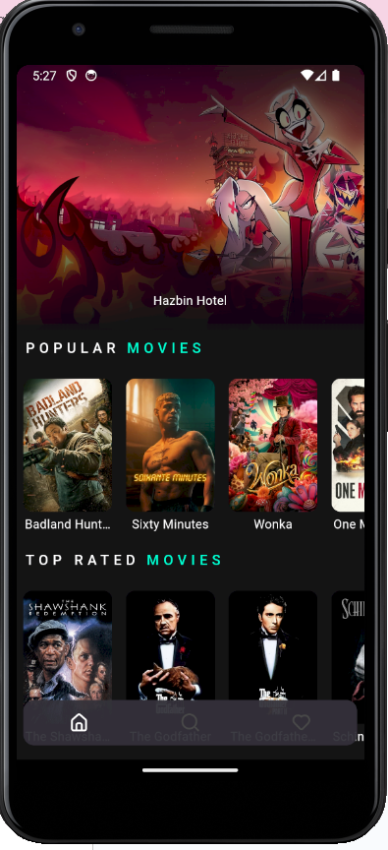

MAD & PWA Lab

Journal

| Experiment No. | 03 |
| --- | --- |
| Experiment Title. | To include icons, images, fonts in Flutter app |
| Roll No. | 49 |
| Name | Gaurang A Roarane |
| Class | D15A |
| Subject | MAD & PWA Lab |
| Lab Outcome | LO2: Design and Develop interactive Flutter App by using widgets, layouts, gestures and animation |
| Grade: | 15 |

**Experiment - 3**

**Aim :-** To include icons, images, [fonts](https://www.youtube.com/watch?v=km2P_KQJyO0) in Flutter app

**Theory:-**

1. Icons:

* Icons are small, visual representations of actions, objects, or concepts. In Flutter, icons can be added using the Icon widget, which allows developers to incorporate a wide range of pre-built icons from the Material Icons library or other icon packs. To use icons, developers simply specify the icon data or icon name within the Icon widget.

1. Images:

* Images are graphical assets that can be used to convey information, illustrate content, or enhance the visual appeal of an app. Flutter provides support for displaying both local and network images using the Image widget. Local images, stored in the project's assets folder, can be imported and displayed using the AssetImage class. Network images can be loaded asynchronously using the NetworkImage class.

1. Fonts:

* Fonts define the visual appearance of text in an app and are instrumental in maintaining brand consistency and UI design. In Flutter, developers can incorporate custom fonts by adding font files (e.g., TrueType or OpenType) to the project and defining font families in the pubspec.yaml file. Once imported, custom fonts can be applied to text using the TextStyle widget by specifying the desired font family.

Integration Process:

* Icons:
  + Import the Material Icons package in the pubspec.yaml file.
  + Use the Icon widget to add icons to Flutter widgets by specifying the icon data or icon name.
* Images:
  + Add image assets to the project's assets folder.
  + Declare the image assets in the pubspec.yaml file.
  + Display images using the Image widget and specifying the image asset path.
* Fonts:
  + Add custom font files (e.g., .ttf, .otf) to the project directory.
  + Define font families in the pubspec.yaml file by specifying the font file paths.
  + Apply custom fonts to text using the TextStyle widget and specifying the font family.

Best Practices:

* Optimize image assets to reduce file size and improve app performance.
* Use vector-based icons whenever possible to ensure scalability and resolution independence.
* Maintain consistency in font usage across the app to reinforce brand identity and enhance readability.
* Test the app on different devices and screen sizes to ensure proper rendering of icons, images, and fonts.

**TVShowScreen.dart**import 'package:flutter/services.dart';

import 'package:intl/intl.dart';

import 'package:flutter/material.dart';

import 'package:osiris/Models/TvShow.dart';

import 'package:osiris/Services/API.dart';

import 'package:osiris/Services/consts.dart';

import 'package:osiris/Widgets/CustomLists.dart';

import 'package:osiris/Widgets/LoadingScreen.dart';

import 'package:osiris/Widgets/SeasonsList.dart';

import 'package:unicons/unicons.dart';

import 'package:osiris/Services/extraServices.dart';

import 'package:osiris/Widgets/DetailScreenComponents.dart';

class TVShowScreen extends StatefulWidget {

TVShowScreen(this.movieId, {super.key});

String movieId;

@override

State<TVShowScreen> createState() => _TVShowScreenState();

}

class _TVShowScreenState extends State<TVShowScreen> {

bool isLoading = true;

late List<TvShow> recommendedTvShows;

Future<void> fetchData() async {

recommendedTvShows =

await APIService().getRecommendedTvShows(widget.movieId);

setState(() {

isLoading = false;

});

}

@override

void initState() {

super.initState();

fetchData();

}

var selectedSeason = 0;

@override

Widget build(BuildContext context) {

var size = MediaQuery.of(context).size;

return Scaffold(

backgroundColor: background_primary,

body: isLoading

? const LoadingScreen()

: FutureBuilder(

future: APIService().getTvShowDetail(widget.movieId),

builder: (context, AsyncSnapshot snapshot) {

if (snapshot.hasData) {

var status = snapshot.data!.status.toString();

var releaseDate = snapshot.data!.firstAirDate.toString();

var seasonCount = snapshot.data!.numberOfSeasons;

var seasonList = [];

for (var i = 1; i <= seasonCount; i++) {

seasonList.add("Season $i");

}

return ListView(

scrollDirection: Axis.vertical,

physics: const AlwaysScrollableScrollPhysics(

parent: BouncingScrollPhysics()),

padding: EdgeInsets.zero,

shrinkWrap: true,

children: [

Stack(

children: [

Container(

width: size.width,

height: size.height * 0.40 > 300

? size.height * 0.40

: 300,

decoration: BoxDecoration(

image: DecorationImage(

image: snapshot.data!.backdropPath == null

? const AssetImage(

"assets/LoadingImage.png")

as ImageProvider

: NetworkImage(

"https://image.tmdb.org/t/p/original${snapshot.data!.backdropPath}",

),

fit: BoxFit.cover,

),

),

),

Container(

width: size.width,

height: size.height * 0.40 > 300

? size.height * 0.40

: 300,

decoration: BoxDecoration(

gradient: LinearGradient(

begin: Alignment.topCenter,

end: Alignment.bottomCenter,

colors: [

Colors.transparent,

Colors.transparent,

background_primary.withOpacity(0.50),

background_primary.withOpacity(0.75),

background_primary.withOpacity(0.85),

background_primary.withOpacity(0.90),

background_primary.withOpacity(0.95),

background_primary.withOpacity(1.00)

]),

),

),

Container(

width: size.width,

height: size.height * 0.35 > 300

? size.height * 0.35

: 300,

margin: const EdgeInsets.all(8),

child: Column(

crossAxisAlignment: CrossAxisAlignment.start,

mainAxisAlignment: MainAxisAlignment.end,

children: [

Text(

snapshot.data!.voteAverage

.toString()

.substring(0, 3),

style: const TextStyle(

fontSize: 40,

fontWeight: FontWeight.w500,

color: Colors.white),

),

Text(

snapshot.data!.name.toString(),

overflow: TextOverflow.ellipsis,

maxLines: 2,

style: const TextStyle(

fontSize: 24,

fontWeight: FontWeight.w500,

color: Colors.white),

),

Row(

children: [

CircularButtons(

UniconsLine.play,

onTap: () {

HapticFeedback.lightImpact();

APIService()

.getTrailerLink(

snapshot.data!.id.toString(),

"tv")

.then(

(value) => LaunchUrl(value));

},

),

CircularButtons(

UniconsLine.plus,

onTap: () {

HapticFeedback.lightImpact();

pshowDialog(

context, widget.movieId, "tv");

},

),

Visibility(

visible: snapshot.data!.adult,

child: CircularButtons(

UniconsLine.eighteen_plus,

onTap: () {},

),

),

],

)

],

),

)

],

),

FutureBuilder(

future:

APIService().getMovieGenres(widget.movieId, "tv"),

builder: (context, AsyncSnapshot snapshot) {

if (snapshot.hasData) {

return Container(

height: 36,

width: size.width,

margin: const EdgeInsets.only(left: 8),

child: ListView.builder(

scrollDirection: Axis.horizontal,

shrinkWrap: true,

physics: const BouncingScrollPhysics(),

itemCount: snapshot.data.length,

itemBuilder: (context, index) {

return TextContainer(

snapshot.data![index].name.toString(),

const EdgeInsets.only(right: 8),

const Color(0xFF14303B));

},

),

);

} else {

return TextContainer(

"Loading",

const EdgeInsets.all(8),

const Color(0xFF14303B));

}

},

),

Column(

crossAxisAlignment: CrossAxisAlignment.start,

children: [

TitleText("Status"),

Row(

children: [

TextContainer(

status,

const EdgeInsets.only(

left: 8, right: 8, bottom: 8),

const Color(0xFF382E39)),

TextContainer(

"Release: ${DateFormat.yMMMMd().format(DateTime.parse(releaseDate))}",

const EdgeInsets.only(

left: 8, right: 8, bottom: 8),

const Color(0xFF545551)),

],

),

TitleText("Overview"),

TextContainer(

snapshot.data!.overview.toString().isEmpty ||

snapshot.data!.overview.toString() ==

"null"

? "No overview available"

: snapshot.data!.overview.toString(),

const EdgeInsets.all(8),

const Color(0xFF0F1D39)),

TitleText("Seasons"),

Container(

height: 36,

width: size.width,

margin: const EdgeInsets.only(left: 8),

child: ListView.builder(

scrollDirection: Axis.horizontal,

shrinkWrap: true,

physics: const BouncingScrollPhysics(),

itemCount: seasonCount,

itemBuilder: (context, index) {

return GestureDetector(

onTap: () {

HapticFeedback.lightImpact();

setState(() {

selectedSeason = index;

});

},

child: TextContainer(

seasonList[index].toString(),

const EdgeInsets.only(right: 8),

index == selectedSeason

? const Color(0xFF545551)

: const Color(0xFF14303B)),

);

},

),

),

SeasonsList(selectedSeason + 1, widget.movieId),

TitleText("Recommendations"),

CustomListTV(recommendedTvShows),

],

)

]);

} else {

return const LoadingScreen();

}

},

),

);

}

}

**SectionText.dart**import 'package:flutter/material.dart';

import 'package:osiris/Services/consts.dart';

Widget SectionText(String ktitle, String ntitle) {

return Container(

width: double.infinity,

margin: const EdgeInsets.all(8),

child: Row(

mainAxisAlignment: MainAxisAlignment.start,

crossAxisAlignment: CrossAxisAlignment.center,

children: [

Padding(

padding: const EdgeInsets.only(right: 8.0),

child: Text(

ktitle.toUpperCase(),

style: const TextStyle(

color: Colors.white,

fontSize: 16,

fontWeight: FontWeight.w500,

letterSpacing: 5),

),

),

Text(

ntitle.toUpperCase(),

style: TextStyle(

color: accent_secondary,

fontSize: 16,

fontWeight: FontWeight.w500,

letterSpacing: 5),

),

],

));

}

**SeasonsList.dart**import 'package:flutter/material.dart';

import 'package:osiris/Services/API.dart';

class SeasonsList extends StatefulWidget {

SeasonsList(this.seasonNumber, this.movieId, {super.key});

int seasonNumber;

String movieId;

@override

State<SeasonsList> createState() => _SeasonsListState();

}

class _SeasonsListState extends State<SeasonsList> {

@override

Widget build(BuildContext context) {

return SizedBox(

height: 150,

child: FutureBuilder(

future: APIService()

.getEpisodes(widget.movieId, widget.seasonNumber.toString()),

builder: (context, AsyncSnapshot snapshot) {

if (snapshot.hasData) {

return ListView.builder(

scrollDirection: Axis.horizontal,

shrinkWrap: true,

physics: const AlwaysScrollableScrollPhysics(

parent: BouncingScrollPhysics()),

itemCount: snapshot.data.length,

itemBuilder: (context, index) {

var url = snapshot.data[index].stillPath.toString();

return Container(

margin: const EdgeInsets.all(10),

decoration: BoxDecoration(

color: const Color(0xFF14303B).withOpacity(0.25),

borderRadius: BorderRadius.circular(10),

border: Border.all(

color: const Color(0xFFA3A3B0).withOpacity(0.5),

width: 0.75,

),

),

child: Column(children: [

Container(

height: 100,

width: 220,

alignment: Alignment.bottomRight,

decoration: BoxDecoration(

borderRadius: const BorderRadius.only(

topLeft: Radius.circular(10),

topRight: Radius.circular(10)),

image: DecorationImage(

image: url == "null"

? const AssetImage("assets/LoadingImage.png")

as ImageProvider

: NetworkImage(

"https://image.tmdb.org/t/p/w500$url"),

fit: BoxFit.cover),

),

child: Container(

margin: const EdgeInsets.all(10),

child: Text(

snapshot.data[index].episodeNumber.toString(),

style: const TextStyle(

color: Colors.white,

fontSize: 24,

shadows: <Shadow>[

Shadow(

offset: Offset(0, 0),

blurRadius: 10,

color: Colors.black,

),

]),

),

),

),

Container(

margin: const EdgeInsets.only(left: 8, top: 4),

width: 200,

child: Text(snapshot.data[index].name.toString(),

textAlign: TextAlign.left,

maxLines: 1,

overflow: TextOverflow.ellipsis,

style: const TextStyle(

color: Colors.white,

)),

),

]),

);

},

);

}

return const Center(child: CircularProgressIndicator());

}),

);

}

}

**Output:-**

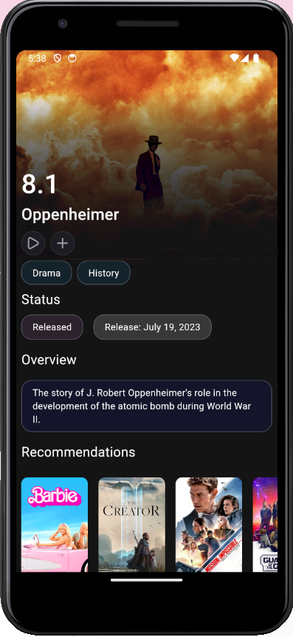

MAD & PWA Lab

Journal

| Experiment No. | 04 |
| --- | --- |
| Experiment Title. | To create an interactive Form using form widget |
| Roll No. | 49 |
| Name | Gaurang A Roarane |
| Class | D15A |
| Subject | MAD & PWA Lab |
| Lab Outcome | LO2: Design and Develop interactive Flutter App by using widgets, layouts, gestures and animation |
| Grade: | 15 |

**Experiment - 4**

**Aim :-** To create an interactive Form using form widget

**Theory:-**

Forms are essential components of user interaction in mobile and web applications, allowing users to input data, make selections, and submit information. In Flutter, the Form widget serves as the foundation for creating interactive and validated forms. Let's explore the theory behind creating an interactive form using the Form widget:

* **Form Widget:**
  + The Form widget in Flutter provides a container for form fields and facilitates form validation and submission.
  + It maintains the state of form fields and manages their validation status.
  + The Form widget should be placed as the parent widget of form fields within the widget tree.
* **Form Fields:**
  + Form fields represent input elements within the form, such as text fields, checkboxes, radio buttons, dropdowns, etc.
  + Flutter provides various built-in form field widgets like TextFormField, Checkbox, Radio, DropdownButton, etc.
  + Each form field widget must be wrapped inside a FormField widget to register with the Form and participate in form validation.
* **Validation:**
  + Form validation ensures that user input meets specified criteria or constraints before submitting the form.
  + Flutter offers built-in validation mechanisms for form fields using validators.
  + Validators are callback functions applied to form fields to validate input data. They return an error message if validation fails.
  + Validators can be synchronous or asynchronous, depending on the complexity of validation logic.
* **Submission:**
  + Once the form is filled out and validated, it can be submitted to process the user input.
  + Form submission involves handling the data collected from form fields and performing any necessary actions, such as saving data to a database, sending it to a server, etc.
  + Submission can be triggered by a button press or any other user action.

**LoginScreen.dart**

import 'package:flutter/material.dart';

import 'package:font_awesome_flutter/font_awesome_flutter.dart';

import 'package:firebase_auth/firebase_auth.dart';

import 'package:osiris/Services/auth.dart';

import 'package:osiris/Services/consts.dart';

import 'package:provider/provider.dart';

import 'package:flutter_svg/flutter_svg.dart';

class LoginScreen extends StatelessWidget {

const LoginScreen({super.key, Key? key1});

@override

Widget build(BuildContext context) {

var size = MediaQuery.of(context).size;

TextEditingController emailController = TextEditingController();

TextEditingController passwordController = TextEditingController();

return Scaffold(

body: Container(

color: background_primary,

child: SafeArea(

child: SingleChildScrollView(

child: Container(

color: background_primary,

height: size.height,

width: size.width,

child: Column(

mainAxisAlignment: MainAxisAlignment.center,

children: [

Container(

height: size.height * 0.3,

),

SvgPicture.asset(

"assets/netflix.svg",

width: size.width * 0.60,

),

Padding(

padding: const EdgeInsets.all(24.0),

child: Column(

children: [

TextFormField(

controller: emailController,

decoration: const InputDecoration(

labelText: 'Email',

filled: true,

fillColor: Colors.white,

),

),

const SizedBox(height: 20),

TextFormField(

controller: passwordController,

decoration: const InputDecoration(

labelText: 'Password',

filled: true,

fillColor: Colors.white,

),

obscureText: true,

),

const SizedBox(height: 20),

ElevatedButton(

onPressed: () async {

try {

await FirebaseAuth.instance

.signInWithEmailAndPassword(

email: emailController.text.trim(),

password: passwordController.text.trim(),

);

// Authentication successful, navigate to next screen

} catch (e) {

// Handle authentication failure

print('Error: $e');

}

},

child: const Text('Sign In with Email'),

),

const SizedBox(height: 20),

ElevatedButton.icon(

onPressed: () {

final provider = Provider.of<GoogleSignInProvider>(

context,

listen: false);

provider.googleLogin();

},

icon: const FaIcon(

FontAwesomeIcons.google,

color: Colors.white,

),

label: const Text(

'Continue with Google',

style: TextStyle(color: Colors.white),

),

style: ElevatedButton.styleFrom(

shape: RoundedRectangleBorder(

borderRadius: BorderRadius.circular(14)),

backgroundColor: const Color(0xFF2A292F)),

),

],

),

),

Container(

margin: const EdgeInsets.fromLTRB(28, 0, 28, 24),

child: Text(

footer_text,

textAlign: TextAlign.center,

style: const TextStyle(color: Color(0xFF423E50)),

),

)

],

),

),

),

),

),

);

}

}

**SignUpScreen.dart**

import 'package:flutter/material.dart';

import 'package:font_awesome_flutter/font_awesome_flutter.dart';

import 'package:firebase_auth/firebase_auth.dart';

import 'package:osiris/Screens/LoginScreen.dart';

import 'package:osiris/Services/auth.dart';

import 'package:osiris/Services/consts.dart';

import 'package:provider/provider.dart';

import 'package:flutter_svg/flutter_svg.dart';

class SignUpScreen extends StatelessWidget {

const SignUpScreen({super.key, Key? key1});

@override

Widget build(BuildContext context) {

var size = MediaQuery.of(context).size;

TextEditingController emailController = TextEditingController();

TextEditingController passwordController = TextEditingController();

TextEditingController confirmPasswordController = TextEditingController();

return Scaffold(

body: Container(

color: background_primary,

child: SafeArea(

child: SingleChildScrollView(

child: Container(

color: background_primary,

height: size.height,

width: size.width,

child: Column(

mainAxisAlignment: MainAxisAlignment.center,

children: [

Container(

height: size.height * 0.2,

),

SvgPicture.asset(

"assets/netflix.svg",

width: size.width * 0.40,

),

Padding(

padding: const EdgeInsets.all(24.0),

child: Column(

children: [

TextFormField(

controller: emailController,

decoration: const InputDecoration(

labelText: 'Email',

filled: true,

fillColor: Colors.white,

),

),

const SizedBox(height: 20),

TextFormField(

controller: passwordController,

decoration: const InputDecoration(

labelText: 'Password',

filled: true,

fillColor: Colors.white,

),

obscureText: true,

),

const SizedBox(height: 20),

TextFormField(

controller: confirmPasswordController,

decoration: const InputDecoration(

labelText: 'Confirm Password',

filled: true,

fillColor: Colors.white,

),

obscureText: true,

),

const SizedBox(height: 20),

ElevatedButton(

onPressed: () async {

if (passwordController.text.trim() == confirmPasswordController.text.trim()) {

try {

await FirebaseAuth.instance

.createUserWithEmailAndPassword(

email: emailController.text.trim(),

password: passwordController.text.trim(),

);

// Sign up successful, navigate to login screen

Navigator.pushReplacement(

context,

MaterialPageRoute(builder: (context) => const LoginScreen()),

);

} catch (e) {

// Handle sign up failure

print('Error: $e');

}

} else {

// Handle password mismatch

print('Error: Passwords do not match');

}

},

child: const Text('Sign Up with Email'),

),

const SizedBox(height: 20),

ElevatedButton.icon(

onPressed: () {

final provider = Provider.of<GoogleSignInProvider>(

context,

listen: false);

provider.googleLogin();

},

icon: const FaIcon(

FontAwesomeIcons.google,

color: Colors.white,

),

label: const Text(

'Continue with Google',

style: TextStyle(color: Colors.white),

),

style: ElevatedButton.styleFrom(

shape: RoundedRectangleBorder(

borderRadius: BorderRadius.circular(14)),

backgroundColor: const Color(0xFF2A292F)),

),

const SizedBox(height: 20),

TextButton(

onPressed: () {

Navigator.push(

context,

MaterialPageRoute(builder: (context) => const LoginScreen()),

);

},

child: const Text(

'Already have an account? Sign In',

style: TextStyle(color: Colors.white),

),

),

],

),

),

Container(

margin: const EdgeInsets.fromLTRB(28, 0, 28, 24),

child: Text(

footer_text,

textAlign: TextAlign.center,

style: const TextStyle(color: Color(0xFF423E50)),

),

)

],

),

),

),

),

),

);

}

}

**Output:-**

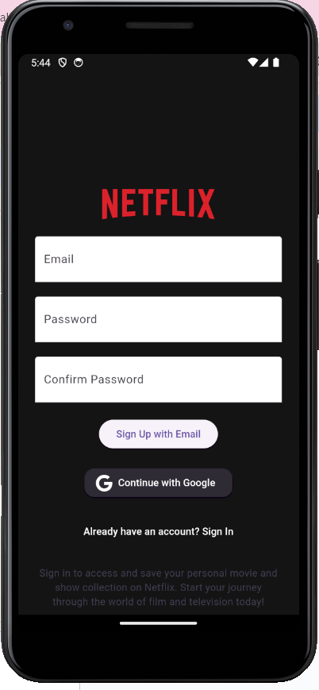 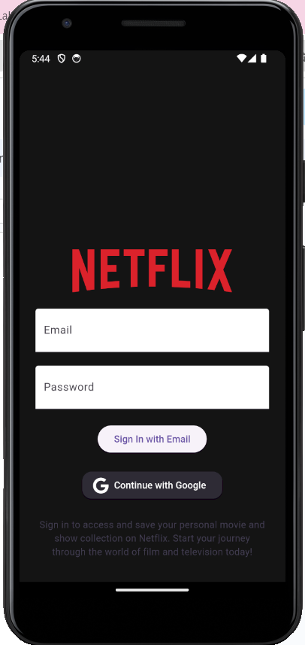

MAD & PWA Lab

Journal

| Experiment No. | 05 |
| --- | --- |
| Experiment Title. | To apply navigation, routing and gestures in Flutter App |
| Roll No. | 49 |
| Name | Gaurang A Roarane |
| Class | D15A |
| Subject | MAD & PWA Lab |
| Lab Outcome | LO2: Design and Develop interactive Flutter App by using widgets, layouts, gestures and animation |
| Grade: | 15 |

**Experiment - 5**

**Aim:-** To apply navigation, routing and gestures in Flutter App

**Theory:-**

Navigation, routing, and gestures are essential aspects of mobile app development that enable users to navigate between screens, interact with app elements, and perform various actions. In Flutter, these features are implemented using widgets and event handlers to create intuitive and engaging user experiences. Let's delve into the theory behind navigation, routing, and gestures in a Flutter app:

* **Navigation and Routing:**
  + Navigation refers to the process of moving between different screens or pages within an app.
  + Routing involves defining the routes or paths that users can take to navigate to specific screens.
  + Flutter provides a built-in routing mechanism using the Navigator widget and MaterialApp widget's routes property to manage app navigation.
  + Routes are mapped to unique route names or paths, making it easy to navigate to a specific screen using its route name.
* **Navigator Widget:**
  + The Navigator widget manages a stack of Route objects representing the app's navigation history.
  + It allows pushing new routes onto the navigation stack, popping routes off the stack, and replacing routes with new ones.
  + Routes can be pushed onto the stack using Navigator.push() and popped using Navigator.pop() methods.
* **Routes:**
  + A route represents a screen or page in the app.
  + Each route is associated with a unique route name and a builder function that constructs the UI for the corresponding screen.
  + Routes can be declared statically using the routes property of MaterialApp or dynamically using the Navigator widget.
* **Gesture Detection:**
  + Gestures enable users to interact with app elements through touch-based actions like tapping, swiping, dragging, pinching, etc.
  + Flutter provides gesture detection widgets such as GestureDetector, InkWell, InkResponse, etc., to handle user input gestures.
  + These widgets detect user gestures and trigger corresponding event handlers to perform specific actions.
* **Gesture Recognition:**
  + Gesture recognition involves identifying and interpreting user gestures to determine the intended action.
  + Flutter's gesture detection widgets come with built-in gesture recognizers that recognize common gestures like taps, drags, long presses, etc.
  + Developers can customize gesture recognition behavior and implement complex gestures using gesture recognizer callbacks.

**BottomNavBar.dart**  
import 'package:flutter/material.dart';

import 'package:go_router/go_router.dart';

import 'package:unicons/unicons.dart';

import 'package:flutter/services.dart';

import 'package:osiris/Services/consts.dart';

class BottomNavBar extends StatefulWidget {

BottomNavBar({Key? key, required this.currentIndex}) : super(key: key);

int currentIndex = 0;

@override

_BottomNavBarState createState() => _BottomNavBarState();

}

class _BottomNavBarState extends State<BottomNavBar> {

@override

Widget build(BuildContext context) {

return Container(

height: 50,

margin: const EdgeInsets.fromLTRB(8, 8, 8, 16),

decoration: BoxDecoration(

color: accent_t.withOpacity(0.95),

borderRadius: BorderRadius.circular(12)),

child: Row(

mainAxisAlignment: MainAxisAlignment.spaceAround,

crossAxisAlignment: CrossAxisAlignment.center,

children: [

IconButton(

icon: Icon(

UniconsLine.home_alt,

color: widget.currentIndex == 0 ? Colors.white : inactive_accent,

),

onPressed: () {

HapticFeedback.mediumImpact();

setState(() {

widget.currentIndex = 0;

});

GoRouter.of(context).go('/main');

},

),

IconButton(

icon: Icon(

UniconsLine.search,

color: widget.currentIndex == 1 ? Colors.white : inactive_accent,

),

onPressed: () {

HapticFeedback.mediumImpact();

setState(() {

widget.currentIndex = 1;

});

GoRouter.of(context).go('/search');

},

),

IconButton(

icon: Icon(

UniconsLine.heart,

color: widget.currentIndex == 2 ? Colors.white : inactive_accent,

),

onPressed: () {

HapticFeedback.mediumImpact();

setState(() {

widget.currentIndex = 2;

});

GoRouter.of(context).go('/profile');

},

),

],

),

);

}

}

**Routes.dart**

import 'package:flutter/material.dart';

import 'package:go_router/go_router.dart';

import 'package:osiris/Screens/LoginScreen.dart';

import 'package:osiris/Screens/MainScreen.dart';

import 'package:osiris/Screens/MovieScreen.dart';

import 'package:osiris/Screens/NavScreen.dart';

import 'package:osiris/Screens/ProfileScreen.dart';

import 'package:osiris/Screens/SearchScreen.dart';

import 'package:osiris/Screens/TvShowScreen.dart';

import 'package:osiris/Screens/SignUpScreen.dart';

GoRouter router = GoRouter(initialLocation: '/', routes: [

GoRoute(

path: '/',

builder: (context, state) => const NavScreen(),

),

GoRoute(

path: '/',

builder: (context, state) => const SignUpScreen(),

pageBuilder: defaultPageBuilder<SignUpScreen>(const SignUpScreen()),

),

GoRoute(

path: '/login',

builder: (context, state) => const LoginScreen(),

pageBuilder: defaultPageBuilder<LoginScreen>(const LoginScreen()),

),

GoRoute(

path: '/main',

builder: (context, state) => const MainScreen(),

pageBuilder: defaultPageBuilder<MainScreen>(const MainScreen()),

),

GoRoute(

path: '/search',

builder: (context, state) => const SearchScreen(),

pageBuilder: defaultPageBuilder<SearchScreen>(const SearchScreen()),

),

GoRoute(

path: '/profile',

builder: (context, state) => const ProfileScreen(),

pageBuilder: defaultPageBuilder<ProfileScreen>(const ProfileScreen()),

),

GoRoute(

path: '/movie/:id',

builder: (context, state) => MovieScreen(state.params['id']!),

),

GoRoute(

path: '/tv/:id',

builder: (context, state) => TVShowScreen(state.params['id']!),

)

]);

CustomTransitionPage buildPageWithDefaultTransition<T>({

required BuildContext context,

required GoRouterState state,

required Widget child,

}) {

return CustomTransitionPage<T>(

key: state.pageKey,

child: child,

transitionsBuilder: (context, animation, secondaryAnimation, child) =>

FadeTransition(opacity: animation, child: child),

);

}

Page<dynamic> Function(BuildContext, GoRouterState) defaultPageBuilder<T>(

Widget child) =>

(BuildContext context, GoRouterState state) {

return buildPageWithDefaultTransition<T>(

context: context,

state: state,

child: child,

);

};

**Output:-**

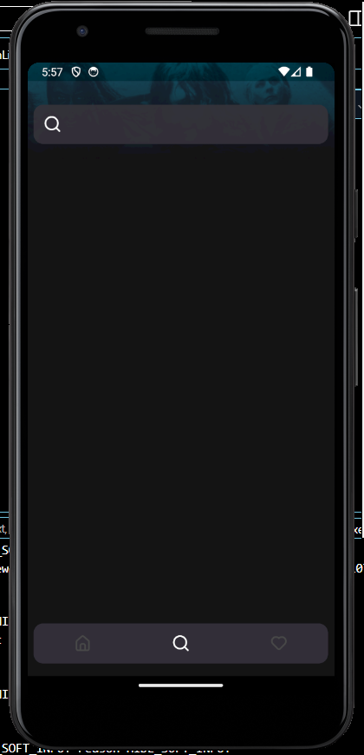

MAD & PWA Lab

Journal

| Experiment No. | 06 |
| --- | --- |
| Experiment Title. | To Connect Flutter UI with fireBase database |
| Roll No. | 49 |
| Name | Gaurang A Roarane |
| Class | D15A |
| Subject | MAD & PWA Lab |
| Lab Outcome | LO3: Analyze and Build production ready Flutter App by incorporating backend services and deploying on Android / iOS |
| Grade: | 15 |

**Experiment - 6**

**Aim:-** To Connect Flutter UI with fireBase database

**Theory:-**

Firebase is a comprehensive platform provided by Google for building mobile and web applications. It offers various services, including a real-time database, authentication, cloud storage, and more. Connecting a Flutter UI with a Firebase database enables developers to store, retrieve, and synchronize data in real-time, providing a seamless experience for users. Let's explore the theory behind connecting Flutter UI with Firebase Database:

* **Firebase Realtime Database:**
  + Firebase Realtime Database is a cloud-hosted NoSQL database that allows developers to store and sync data between users in real-time.
  + It provides a JSON-based data model, making it easy to organize and structure data.
  + The database automatically synchronizes data across all connected clients, ensuring that changes made by one client are immediately reflected on other clients.
* **Firebase SDK for Flutter:**
  + Google provides the Firebase Flutter plugin, which allows Flutter apps to integrate seamlessly with Firebase services.
  + The Firebase plugin for Flutter provides APIs to interact with Firebase services, including authentication, database, cloud storage, etc.
  + It simplifies the process of connecting Flutter apps to Firebase services, enabling developers to focus on building the app's functionality.
* **Integration Process:**
  + Step 1: Set up Firebase Project:
    - Create a Firebase project from the Firebase Console (https://console.firebase.google.com).
    - Add your Flutter app to the Firebase project by registering its package name.
    - Download the google-services.json configuration file and place it in the android/app directory of your Flutter project.
  + Step 2: Configure Flutter Project:
    - Add the Firebase Flutter plugin to your Flutter project by adding the necessary dependencies in the pubspec.yaml file.
    - Initialize Firebase in your Flutter app by calling Firebase.initializeApp() in the main() function.
  + Step 3: Access Firebase Database:
    - Use the Firebase Database SDK for Flutter to interact with the Firebase Realtime Database.
    - Create references to database locations using the FirebaseDatabase class.
    - Perform CRUD (Create, Read, Update, Delete) operations on the database using methods like set(), push(), update(), remove(), etc.
  + Step 4: Display Data in Flutter UI:
    - Retrieve data from the Firebase database and display it in the Flutter UI.
    - Use Flutter widgets like ListView, GridView, Text, Image, etc., to render database content in the app's UI.
    - Implement real-time data synchronization to automatically update the UI when changes occur in the database.

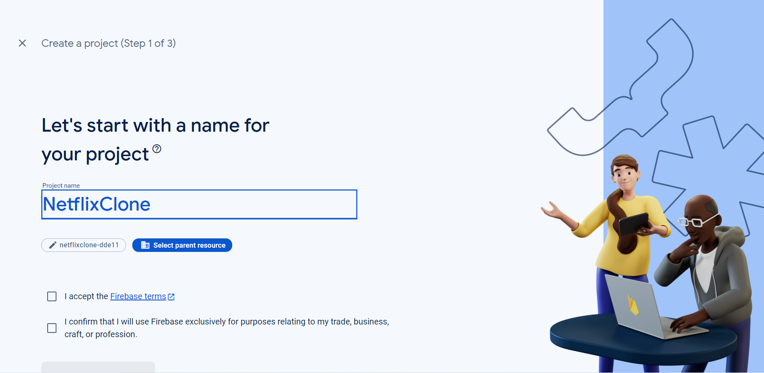

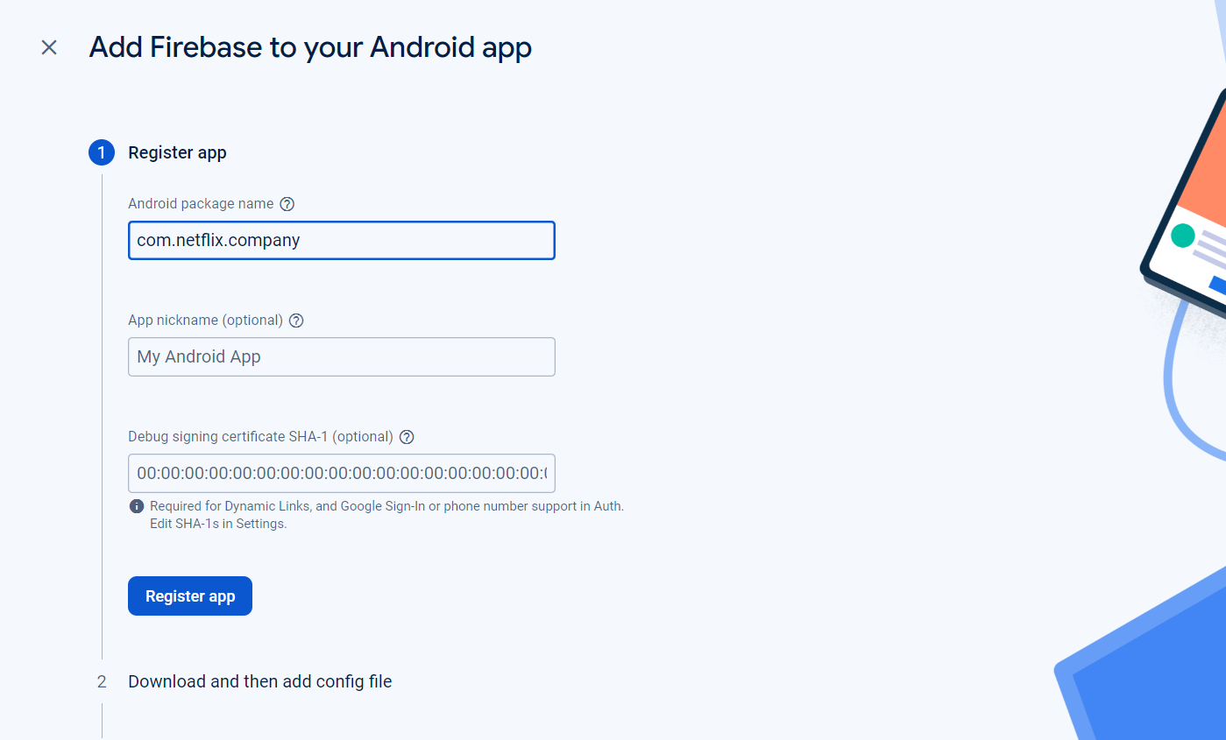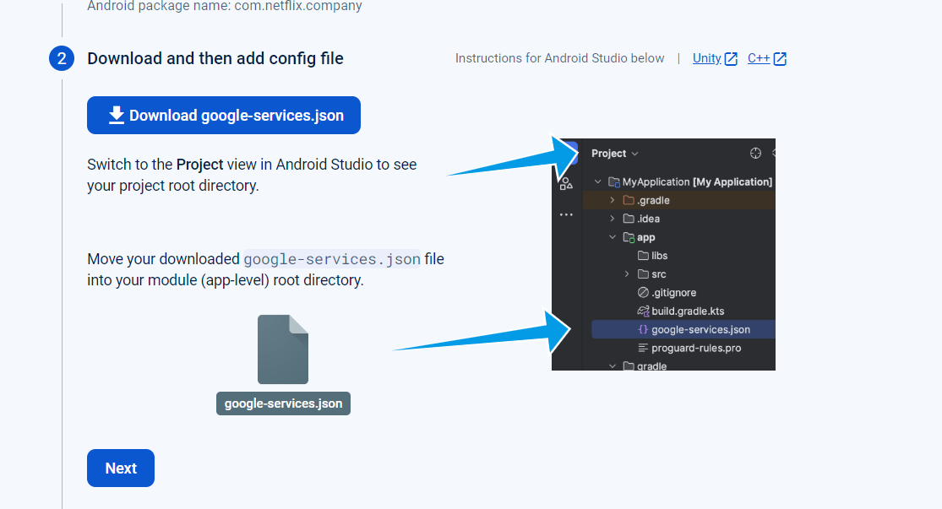

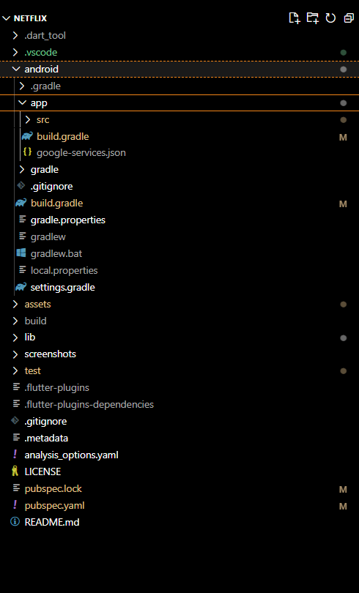

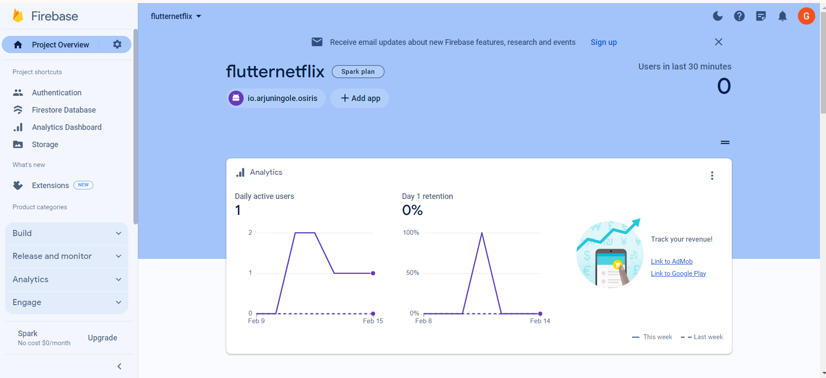

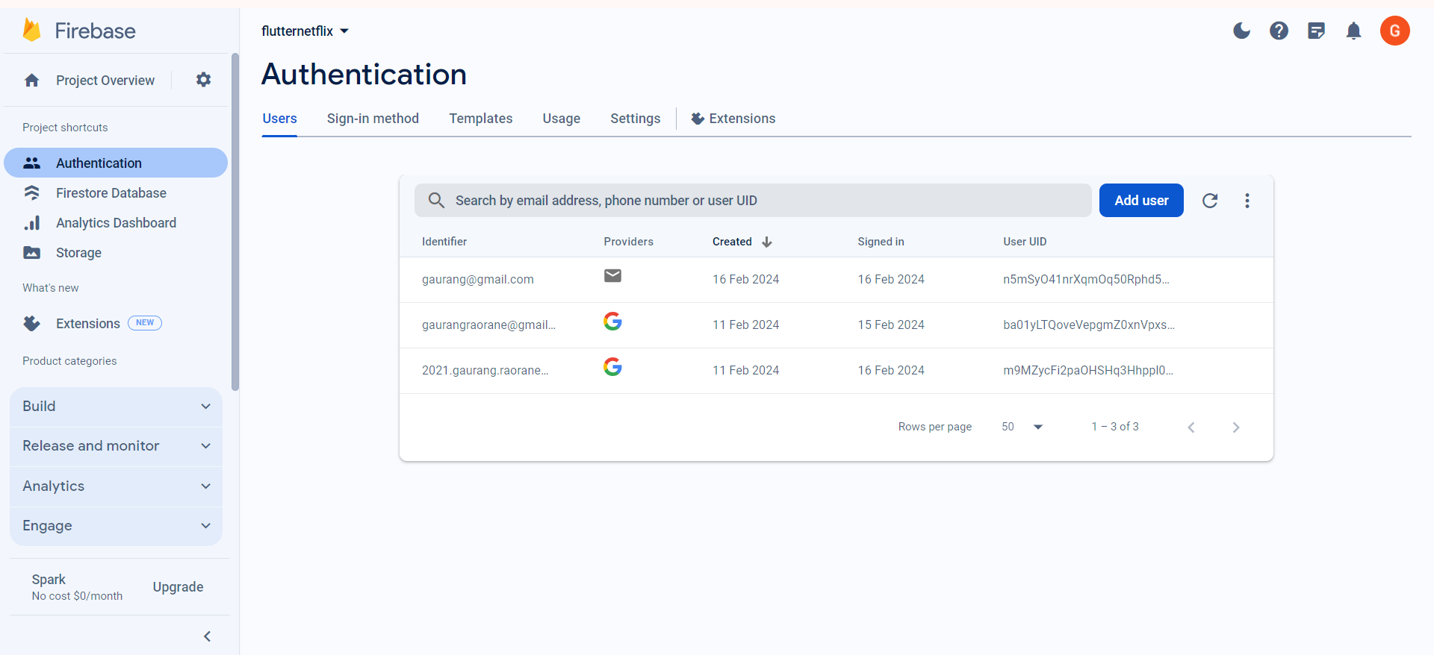

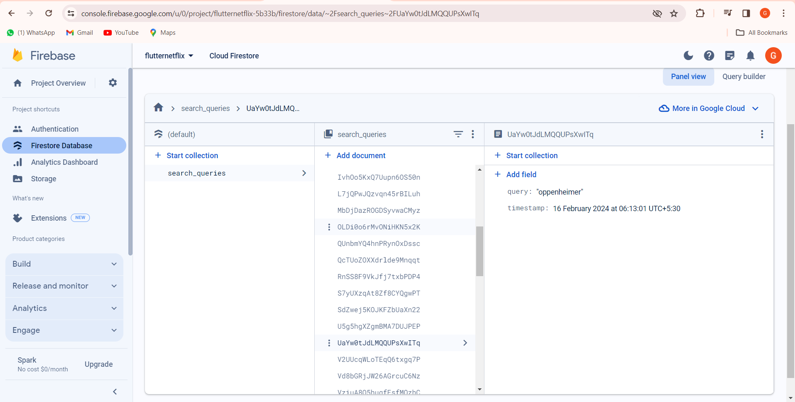

Hence Firebase is Successfully Connected.

MAD & PWA Lab

Journal

| Experiment No. | 07 |
| --- | --- |
| Experiment Title. | To write meta data of your Ecommerce PWA in a Web app manifest file to enable “add to homescreen feature”. |
| Roll No. | 49 |
| Name | Gaurang A Roarane |
| Class | D15A |
| Subject | MAD & PWA Lab |
| Lab Outcome | LO4: Understand various PWA frameworks and their requirements |
| Grade: | 15 |

Experiment - 7

Aim - To write meta data of your Ecommerce PWA in a Web app manifest file to enable add to homescreen feature.

Theory -

It's clear that PWAs offer several advantages over traditional web apps, particularly in terms of providing a more native-like experience, ease of access, faster services, engaging features, and real-time data access.

PWAs leverage modern web technologies and principles to deliver a more app-like experience to users while maintaining the flexibility and accessibility of web apps. By incorporating features such as service workers, PWAs can offer offline capabilities, faster loading times, and seamless updates without requiring users to download or install new versions manually.

The key features of PWAs that distinguish them from regular web apps include:

1. Progressive Enhancement: PWAs are built with progressive improvement principles, ensuring that they work for every user regardless of the browser or device they are using.

2. Responsive Design: PWAs adapt to various screen sizes and orientations, providing a consistent user experience across desktops, mobile devices, and tablets.

3. App-like Experience: PWAs behave like native apps in terms of interaction and navigation, providing a smoother and more immersive user experience.

4. Automatic Updates: PWAs can receive updates automatically from the server, ensuring that users always have access to the latest features and content without needing to manually update the app.

5. Security: PWAs are served over HTTPS to ensure secure connections and prevent unauthorized access or tampering of data.

6. Search Engine Indexing: PWAs are identified as applications and can be indexed by search engines, improving discoverability and visibility.

7. Reactivatable: PWAs make it easy for users to reactivate the application and receive notifications, enhancing user engagement and retention.

Overall, PWAs represent a significant advancement in web app development, offering a compelling alternative to traditional native apps with their enhanced performance, user experience, and accessibility across various platforms and devices.

**Code -**

**Index.html**

<!DOCTYPE html>

<html lang="en">

<head>

<meta charset="UTF-8">

<meta http-equiv="X-UA-Compatible" content="IE=edge">

<meta name="viewport" content="width=device-width, initial-scale=1.0">

<meta name="theme-color" content="#4285f4">

<meta name="viewport"

content="width=device-width,

initial-scale=1">

<meta http-equiv="X-UA-Compatible"

content="ie=edge">

<title>Glowing - Reveal The Beauty of Skin</title>

<link rel="shortcut icon" href="./favicon.svg" type="image/svg+xml">

<link rel="stylesheet" href="./assets/css/style.css">

<link rel="preconnect" href="https://fonts.googleapis.com">

<link rel="preconnect" href="https://fonts.gstatic.com" crossorigin>

<link href="https://fonts.googleapis.com/css2?family=Urbanist:wght@400;500;600;700;800&display=swap" rel="stylesheet">

<link rel="preload" as="image" href="./assets/images/logo.png">

<link rel="preload" as="image" href="./assets/images/hero-banner-1.jpg">

<link rel="preload" as="image" href="./assets/images/hero-banner-2.jpg">

<link rel="preload" as="image" href="./assets/images/hero-banner-3.jpg">

<link rel="manifest" href="manifest.json">

<script src="serviceworker.js"></script>

</head>

<body id="top">

<script>

// Add event listener to execute code when page loads

window.addEventListener('load', () => {

// Call registerSW function when page loads

registerSW();

});

// Register the Service Worker

async function registerSW() {

// Check if browser supports Service Worker

if ('serviceWorker' in navigator) {

try {

// Register the Service Worker named 'serviceworker.js'

await navigator.serviceWorker.register('serviceworker.js');

}

catch (e) {

// Log error message if registration fails

console.error('ServiceWorker registration failed: ', e);

}

}

}

if ('Notification' in window) {

Notification.requestPermission().then(function (permission) {

if (permission === 'granted') {

console.log('Notification permission granted.');

} else {

console.warn('Notification permission denied.');

}

});

}

</script>

<header class="header">

<div class="alert">

<div class="container">

<p class="alert-text">Free Shipping On All U.S. Orders $50+</p>

</div>

</div>

<div class="header-top" data-header>

<div class="container">

<button class="nav-open-btn" aria-label="open menu" data-nav-toggler>

<span class="line line-1"></span>

<span class="line line-2"></span>

<span class="line line-3"></span>

</button>

<div class="input-wrapper">

<input type="search" name="search" placeholder="Search product" class="search-field">

<button class="search-submit" aria-label="search">

<ion-icon name="search-outline" aria-hidden="true"></ion-icon>

</button>

</div>

<a href="#" class="logo">

<img src="./assets/images/logo.png" width="179" height="26" alt="Glowing">

</a>

<div class="header-actions">

<button class="header-action-btn" aria-label="user">

<ion-icon name="person-outline" aria-hidden="true" aria-hidden="true"></ion-icon>

</button>

<button class="header-action-btn" aria-label="favourite item">

<ion-icon name="star-outline" aria-hidden="true" aria-hidden="true"></ion-icon>

<span class="btn-badge">0</span>

</button>

<button class="header-action-btn" aria-label="cart item">

<data class="btn-text" value="0">$0.00</data>

<ion-icon name="bag-handle-outline" aria-hidden="true" aria-hidden="true"></ion-icon>

<span class="btn-badge">0</span>

</button>

</div>

<nav class="navbar">

<ul class="navbar-list">

<li>

<a href="#home" class="navbar-link has-after">Home</a>

</li>

<li>

<a href="#collection" class="navbar-link has-after">Collection</a>

</li>

<li>

<a href="#shop" class="navbar-link has-after">Shop</a>

</li>

<li>

<a href="#offer" class="navbar-link has-after">Offer</a>

</li>

<li>

<a href="#blog" class="navbar-link has-after">Blog</a>

</li>

</ul>

</nav>

</div>

</div>

</header>

<div class="sidebar">

<div class="mobile-navbar" data-navbar>

<div class="wrapper">

<a href="#" class="logo">

<img src="./assets/images/logo.png" width="179" height="26" alt="Glowing">

</a>

<button class="nav-close-btn" aria-label="close menu" data-nav-toggler>

<ion-icon name="close-outline" aria-hidden="true"></ion-icon>

</button>

</div>

<ul class="navbar-list">

<li>

<a href="#home" class="navbar-link" data-nav-link>Home</a>

</li>

<li>

<a href="#collection" class="navbar-link" data-nav-link>Collection</a>

</li>

<li>

<a href="#shop" class="navbar-link" data-nav-link>Shop</a>

</li>

<li>

<a href="#offer" class="navbar-link" data-nav-link>Offer</a>

</li>

<li>

<a href="#blog" class="navbar-link" data-nav-link>Blog</a>

</li>

</ul>

</div>

<div class="overlay" data-nav-toggler data-overlay></div>

</div>

<main>

<article>

<section class="section hero" id="home" aria-label="hero" data-section>

<div class="container">

<ul class="has-scrollbar">

<li class="scrollbar-item">

<div class="hero-card has-bg-image" style="background-image: url('./assets/images/hero-banner-1.jpg')">

<div class="card-content">

<h1 class="h1 hero-title">

Reveal The <br>

Beauty of Skin

</h1>

<p class="hero-text">

Made using clean, non-toxic ingredients, our products are designed for everyone.

</p>

<p class="price">Starting at $7.99</p>

<a href="#" class="btn btn-primary">Shop Now</a>

</div>

</div>

</li>

<li class="scrollbar-item">

<div class="hero-card has-bg-image" style="background-image: url('./assets/images/hero-banner-2.jpg')">

<div class="card-content">

<h1 class="h1 hero-title">

Reveal The <br>

Beauty of Skin

</h1>

<p class="hero-text">

Made using clean, non-toxic ingredients, our products are designed for everyone.

</p>

<p class="price">Starting at $7.99</p>

<a href="#" class="btn btn-primary">Shop Now</a>

</div>

</div>

</li>

<li class="scrollbar-item">

<div class="hero-card has-bg-image" style="background-image: url('./assets/images/hero-banner-3.jpg')">

<div class="card-content">

<h1 class="h1 hero-title">

Reveal The <br>

Beauty of Skin

</h1>

<p class="hero-text">

Made using clean, non-toxic ingredients, our products are designed for everyone.

</p>

<p class="price">Starting at $7.99</p>

<a href="#" class="btn btn-primary">Shop Now</a>

</div>

</div>

</li>

</ul>

</div>

</section>

<!--

- #COLLECTION

-->

<section class="section collection" id="collection" aria-label="collection" data-section>

<div class="container">

<ul class="collection-list">

<li>

<div class="collection-card has-before hover:shine">

<h2 class="h2 card-title">Summer Collection</h2>

<p class="card-text">Starting at $17.99</p>

<a href="#" class="btn-link">

<span class="span">Shop Now</span>

<ion-icon name="arrow-forward" aria-hidden="true"></ion-icon>

</a>

<div class="has-bg-image" style="background-image: url('./assets/images/collection-1.jpg')"></div>

</div>

</li>

<li>

<div class="collection-card has-before hover:shine">

<h2 class="h2 card-title">What’s New?</h2>

<p class="card-text">Get the glow</p>

<a href="#" class="btn-link">

<span class="span">Discover Now</span>

<ion-icon name="arrow-forward" aria-hidden="true"></ion-icon>

</a>

<div class="has-bg-image" style="background-image: url('./assets/images/collection-2.jpg')"></div>

</div>

</li>

<li>

<div class="collection-card has-before hover:shine">

<h2 class="h2 card-title">Buy 1 Get 1</h2>

<p class="card-text">Starting at $7.99</p>

<a href="#" class="btn-link">

<span class="span">Discover Now</span>

<ion-icon name="arrow-forward" aria-hidden="true"></ion-icon>

</a>

<div class="has-bg-image" style="background-image: url('./assets/images/collection-3.jpg')"></div>

</div>

</li>

</ul>

</div>

</section>

<!--

- #SHOP

-->

<section class="section shop" id="shop" aria-label="shop" data-section>

<div class="container">

<div class="title-wrapper">

<h2 class="h2 section-title">Our Bestsellers</h2>

<a href="#" class="btn-link">

<span class="span">Shop All Products</span>

<ion-icon name="arrow-forward" aria-hidden="true"></ion-icon>

</a>

</div>

<ul class="has-scrollbar">

<li class="scrollbar-item">

<div class="shop-card">

<div class="card-banner img-holder" style="--width: 540; --height: 720;">

<img src="./assets/images/product-01.jpg" width="540" height="720" loading="lazy"

alt="Facial cleanser" class="img-cover">

<span class="badge" aria-label="20% off">-20%</span>

<div class="card-actions">

<button class="action-btn" aria-label="add to cart">

<ion-icon name="bag-handle-outline" aria-hidden="true"></ion-icon>

</button>

<button class="action-btn" aria-label="add to whishlist">

<ion-icon name="star-outline" aria-hidden="true"></ion-icon>

</button>

<button class="action-btn" aria-label="compare">

<ion-icon name="repeat-outline" aria-hidden="true"></ion-icon>

</button>

</div>

</div>

<div class="card-content">

<div class="price">

<del class="del">$39.00</del>

<span class="span">$29.00</span>

</div>

<h3>

<a href="#" class="card-title">Facial cleanser</a>

</h3>

<div class="card-rating">

<div class="rating-wrapper" aria-label="5 start rating">

<ion-icon name="star" aria-hidden="true"></ion-icon>

<ion-icon name="star" aria-hidden="true"></ion-icon>

<ion-icon name="star" aria-hidden="true"></ion-icon>

<ion-icon name="star" aria-hidden="true"></ion-icon>

<ion-icon name="star" aria-hidden="true"></ion-icon>

</div>

<p class="rating-text">5170 reviews</p>

</div>

</div>

</div>

</li>

<li class="scrollbar-item">

<div class="shop-card">

<div class="card-banner img-holder" style="--width: 540; --height: 720;">

<img src="./assets/images/product-02.jpg" width="540" height="720" loading="lazy"

alt="Bio-shroom Rejuvenating Serum" class="img-cover">

<div class="card-actions">

<button class="action-btn" aria-label="add to cart">

<ion-icon name="bag-handle-outline" aria-hidden="true"></ion-icon>

</button>

<button class="action-btn" aria-label="add to whishlist">

<ion-icon name="star-outline" aria-hidden="true"></ion-icon>

</button>

<button class="action-btn" aria-label="compare">

<ion-icon name="repeat-outline" aria-hidden="true"></ion-icon>

</button>

</div>

</div>

<div class="card-content">

<div class="price">

<span class="span">$29.00</span>

</div>

<h3>

<a href="#" class="card-title">Bio-shroom Rejuvenating Serum</a>

</h3>

<div class="card-rating">

<div class="rating-wrapper" aria-label="5 start rating">

<ion-icon name="star" aria-hidden="true"></ion-icon>

<ion-icon name="star" aria-hidden="true"></ion-icon>

<ion-icon name="star" aria-hidden="true"></ion-icon>

<ion-icon name="star" aria-hidden="true"></ion-icon>

<ion-icon name="star" aria-hidden="true"></ion-icon>

</div>

<p class="rating-text">5170 reviews</p>

</div>

</div>

</div>

</li>

………………………………

<script>

// Add event listener to execute code when page loads

window.addEventListener('load', () => {

// Call registerSW function when page loads

registerSW();

});

// Register the Service Worker

async function registerSW() {

// Check if browser supports Service Worker

if ('serviceWorker' in navigator) {

try {

// Register the Service Worker named 'serviceworker.js'

await navigator.serviceWorker.register('serviceworker.js');

}

catch (e) {

// Log error message if registration fails

console.error('ServiceWorker registration failed: ', e);

}

}

}

if ('Notification' in window) {

Notification.requestPermission().then(function (permission) {

if (permission === 'granted') {

console.log('Notification permission granted.');

} else {

console.warn('Notification permission denied.');

}

});

}

</script>

{

"name":"PWA Tutorial",

"short_name":"PWA",

"start_url":"index.html",

"display":"standalone",

"background_color":"#5900b3",

"theme_color":"black",

"scope": ".",

"description":"This is a PWA tutorial.",

"icons":[

{

"src":"icon-192x192.png",

"sizes":"192x192",

"type":"image/png",

"purpose":"any maskable"

},

{

"src":"icon-512x512.png",

"sizes":"512x512",

"type":"image/png",

"purpose":"any maskable"

}

]

}

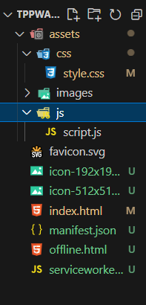

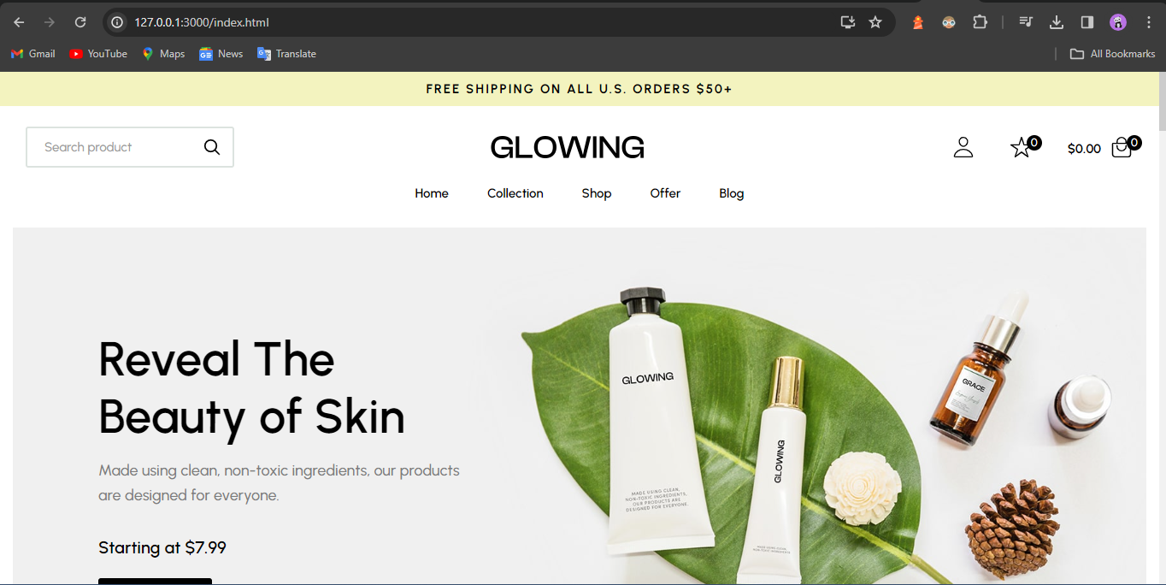

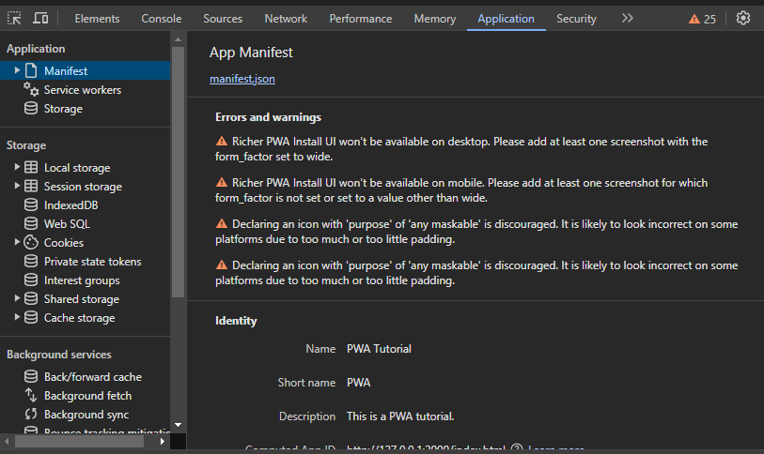

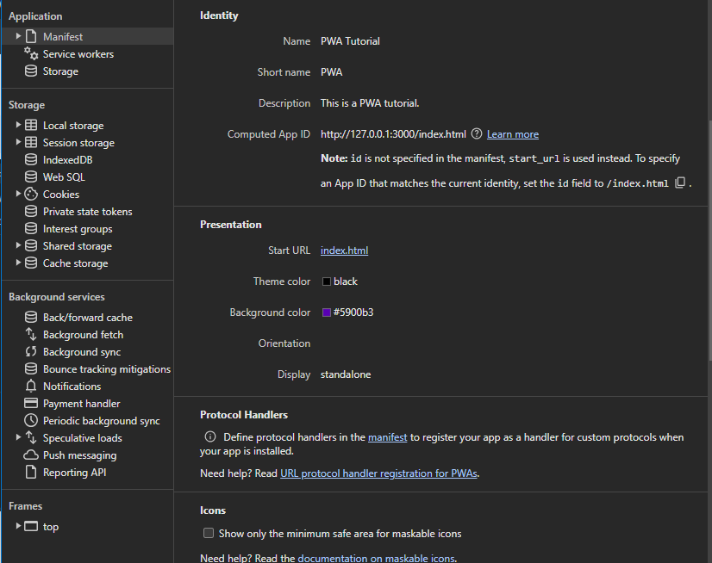

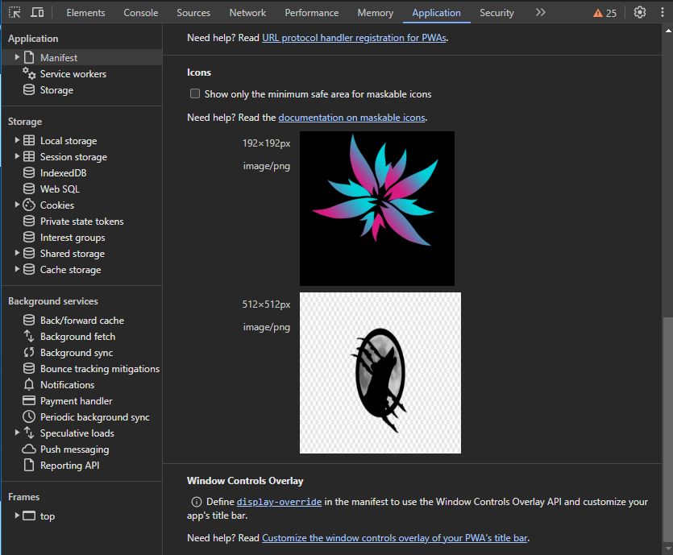

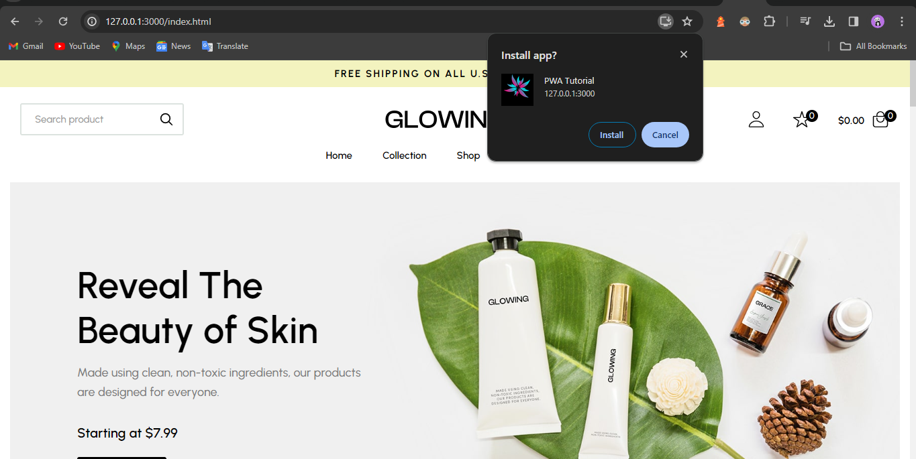

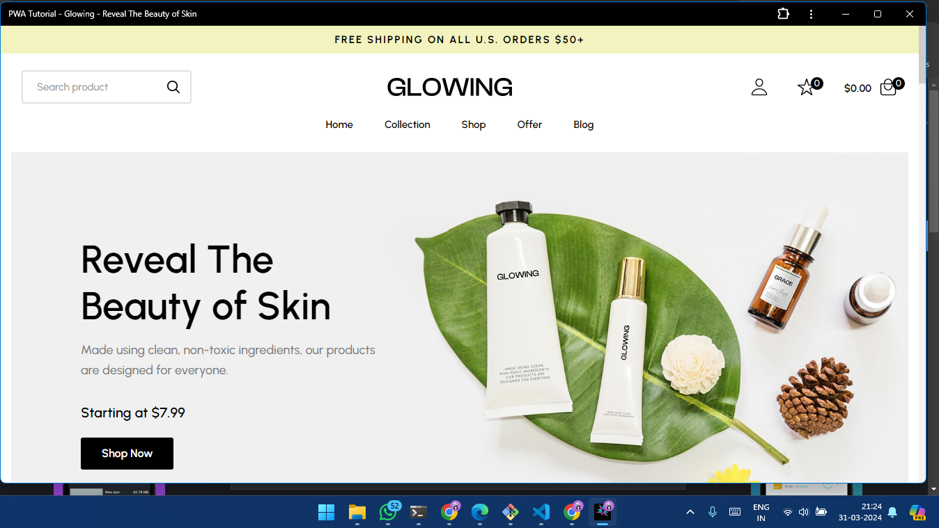

Conclusion -

In this experiment, we have successfully created a basic progressive web app of our web page and installed it in our desktop successfully.

MAD & PWA Lab

Journal

| Experiment No. | 08 |
| --- | --- |
| Experiment Title. | To code and register a service worker, and complete the install and activation process for a new service worker for the E-commerce PWA |
| Roll No. | 49 |
| Name | Gaurang A Roarane |
| Class | D15A |
| Subject | MAD & PWA Lab |
| Lab Outcome | LO5: Design and Develop a responsive User Interface by applying PWA Design techniques |
| Grade: | 15 |

Experiment - 8

**Aim -** To code and register a service worker, and complete the install and activation process for a new service worker for the E-commerce PWA.

**Theory -**

Service Worker is a script that operates independently in the background of a browser, acting as a programmable network proxy. It enables developers to control how network requests from a web page are handled. It's crucial to note that Service Workers only function over HTTPS due to security concerns, as they have the capability to intercept network requests and modify responses.

Here's a summary of what you can do and can't do with Service Workers:

What You Can Do:

1. Dominate Network Traffic: You can manage all network traffic of the page and manipulate requests and responses as needed. This includes altering responses for different types of requests.

2. Cache Content: Service Workers allow caching of request/response pairs using the Cache API. This enables offline access to cached content, improving performance and user experience.

3. Manage Push Notifications: You can handle push notifications with Service Workers, allowing you to display messages to users even when the internet connection is broken.

4. Background Sync: Service Workers facilitate background processes, enabling tasks to continue despite interruptions in internet connectivity.

What You Can't Do:

1. Access the Window: Service Workers cannot access the window or manipulate DOM elements directly. Communication with the window is possible through postMessage.

2. Work on Port 80: Service Workers only function on HTTPS, but during development, they can operate on localhost.

Registration:

To install a Service Worker, it must be registered in the main JavaScript code. This registration informs the browser where the Service Worker is located and initiates the installation process in the background.

Installation:

Once registered, the browser attempts to install the Service Worker if it's considered new or updated. This triggers an install event, during which tasks such as precaching parts of the web app can be performed to enhance subsequent loading times.

Overall, Service Workers offer powerful capabilities for enhancing web applications, particularly in terms of offline functionality, network traffic management, and push notifications. However, developers must be mindful of security considerations and the limitations imposed by the Service Worker environment.

**Code -**

Serviceworker.js

const CACHE_NAME = 'my-ecommerce-app-cache-v1';

const urlsToCache = [

'/',

'index.html',

'assets/js/script.js',

'assets/css/style.css',

'serviceworker.js',

'manifest.json',

'offline.html'

// Add more files to cache as needed

];

self.addEventListener('install', function(event) {

event.waitUntil(

caches.open(CACHE_NAME)

.then(function(cache) {

console.log('Opened cache');

return cache.addAll(urlsToCache)

.catch(function(error) {

console.error('Cache.addAll error:', error);

});

})

);

});

self.addEventListener('activate', function(event) {

// Perform activation steps

event.waitUntil(

caches.keys().then(function(cacheNames) {

return Promise.all(

cacheNames.map(function(cacheName) {

if (cacheName !== CACHE_NAME) {

return caches.delete(cacheName);

}

})

);

})

);

});

self.addEventListener('activate', async () => {

if (Notification.permission !== 'granted') {

try {

const permission = await Notification.requestPermission();

if (permission === 'granted') {

console.log('Notification permission granted.');

} else {

console.warn('Notification permission denied.');

}

} catch (error) {

console.error('Failed to request notification permission:', error);

}

}

});

manifest.js

{

"name":"PWA Tutorial",

"short_name":"PWA",

"start_url":"index.html",

"display":"standalone",

"background_color":"#5900b3",

"theme_color":"black",

"scope": ".",

"description":"This is a PWA tutorial.",

"icons":[

{

"src":"icon-192x192.png",

"sizes":"192x192",

"type":"image/png",

"purpose":"any maskable"

},

{

"src":"icon-512x512.png",

"sizes":"512x512",

"type":"image/png",

"purpose":"any maskable"

}

]

}

**Offline.html**

<!DOCTYPE html>

<html lang="en">

<head>

<meta charset="UTF-8">

<meta name="viewport" content="width=device-width, initial-scale=1.0">

<title>Offline</title>

<style>

body {

font-family: Arial, sans-serif;

background-color: #f0f0f0;

color: #333;

text-align: center;

padding: 50px;

}

h1 {

margin-bottom: 20px;

}

</style>

</head>

<body>

<h1>Oops! You're offline.</h1>

<p>It seems like you're currently offline. Please check your internet connection and try again later.</p>

</body>

</html>

script.js-

'use strict';

const addEventOnElem = function (elem, type, callback) {

if (elem.length > 1) {

for (let i = 0; i < elem.length; i++) {

elem[i].addEventListener(type, callback);

}

} else {

elem.addEventListener(type, callback);

}

}

const navTogglers = document.querySelectorAll("[data-nav-toggler]");

const navbar = document.querySelector("[data-navbar]");

const navbarLinks = document.querySelectorAll("[data-nav-link]");

const overlay = document.querySelector("[data-overlay]");

const toggleNavbar = function () {

navbar.classList.toggle("active");

overlay.classList.toggle("active");

}

addEventOnElem(navTogglers, "click", toggleNavbar);

const closeNavbar = function () {

navbar.classList.remove("active");

overlay.classList.remove("active");

}

addEventOnElem(navbarLinks, "click", closeNavbar);

const header = document.querySelector("[data-header]");

const backTopBtn = document.querySelector("[data-back-top-btn]");

const headerActive = function () {

if (window.scrollY > 150) {

header.classList.add("active");

backTopBtn.classList.add("active");

} else {

header.classList.remove("active");

backTopBtn.classList.remove("active");

}

}

addEventOnElem(window, "scroll", headerActive);

let lastScrolledPos = 0;

const headerSticky = function () {

if (lastScrolledPos >= window.scrollY) {

header.classList.remove("header-hide");

} else {

header.classList.add("header-hide");

}

lastScrolledPos = window.scrollY;

}

addEventOnElem(window, "scroll", headerSticky);

const sections = document.querySelectorAll("[data-section]");

const scrollReveal = function () {

for (let i = 0; i < sections.length; i++) {

if (sections[i].getBoundingClientRect().top < window.innerHeight / 2) {

sections[i].classList.add("active");

}

}

}

scrollReveal();

addEventOnElem(window, "scroll", scrollReveal);

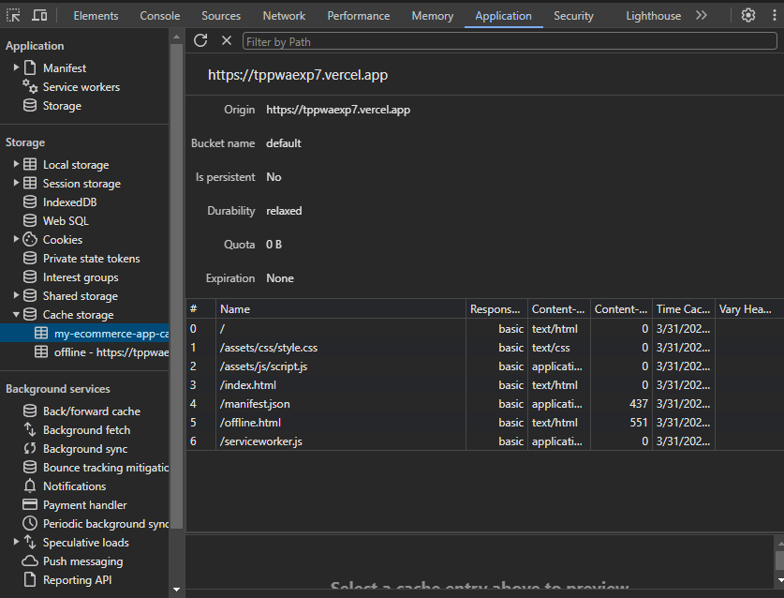

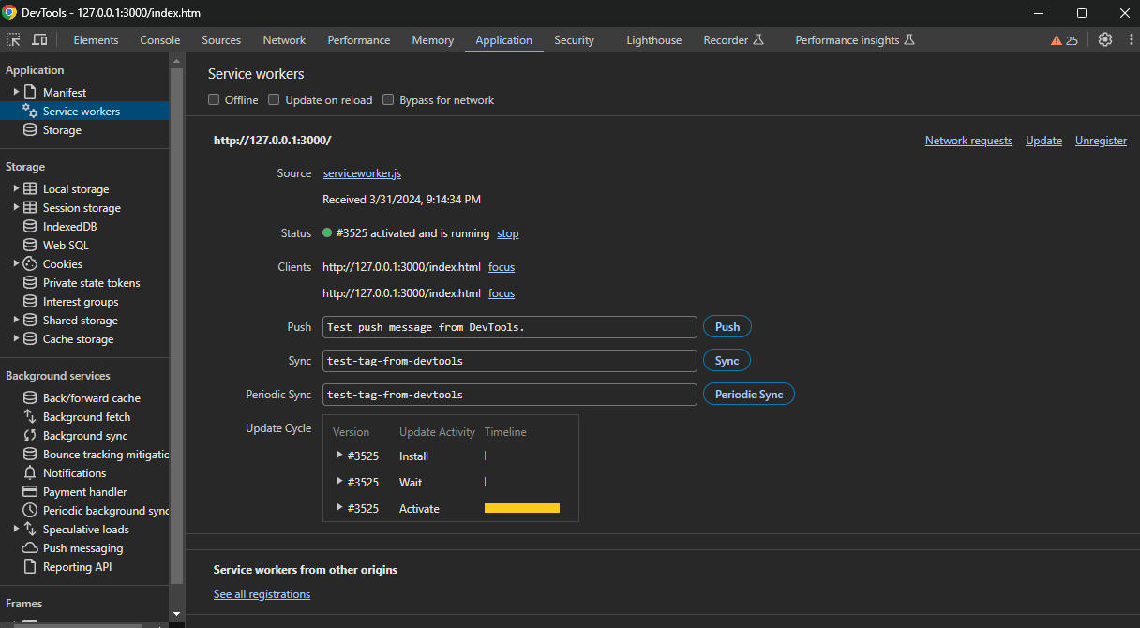

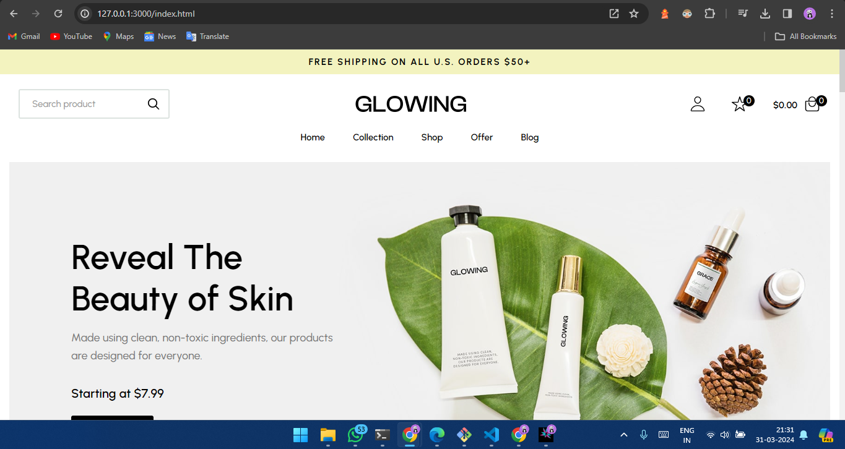

Conclusion -

In this experiment, we have registered a service worker, and completed the install and activation process for a new service worker for the E-commerce PWA.

MAD & PWA Lab

Journal

| Experiment No. | 09 |
| --- | --- |
| Experiment Title. | To implement Service worker events like fetch, sync and push for E-commerce PWA |
| Roll No. | 49 |
| Name | Gaurang A Roarane |
| Class | D15A |
| Subject | MAD & PWA Lab |
| Lab Outcome | LO5: Design and Develop a responsive User Interface by applying PWA Design techniques |
| Grade: | 15 |

Experiment - 9

Aim - To implement Service worker events like fetch, sync and push for E-commerce PWA.

Theory -

Service Worker is a powerful script that operates in the background of a browser independently, similar to a proxy working on the user's side. It allows developers to track network traffic, manage push notifications, and develop "offline-first" web applications using the Cache API. Here are some important aspects to note about Service Workers:

- Programmable Network Proxy: Service Worker acts as a programmable network proxy, giving developers control over how network requests from their web page are handled.

- HTTPS Requirement: Service Workers only function over HTTPS due to security reasons. They can intercept network requests and modify responses, so running them over insecure connections could pose significant security risks.

- Idle State and Restart: When not in use, a Service Worker becomes idle and restarts when needed next. Developers can't rely on a global state persisting between events. IndexedDB databases can be used to persist and reuse information across restarts.

- Fetch Event: This event allows tracking and managing of page network traffic. Developers can implement strategies such as "cache first" and "network first" approaches. For example:

- CacheFirst: If the requested resource is cached, return the cached response; otherwise, request a new response from the network.

- NetworkFirst: Attempt to get an updated response from the network. If successful, cache and return the new response. If unsuccessful, check if the request is cached and return it if available.

- Sync Event: Background Sync API delays a process until the internet connection is stable. For example, in an email client application, if the internet connection is lost while composing an email, Background Sync can ensure the email is sent once the connection is restored.

- Push Event: Handles push notifications received from the server. Developers can apply various actions based on received data. For instance, displaying a notification to the user. The `Notification.requestPermission();` line is necessary to show notifications to the user.

Service Workers offer developers extensive capabilities for enhancing web applications, including offline functionality, network traffic management, and push notifications. However, they require careful implementation due to security considerations and their asynchronous nature.

Code -

Service worker.js

const CACHE_NAME = 'my-ecommerce-app-cache-v1';

const urlsToCache = [

'/',

'index.html',

'assets/js/script.js',

'assets/css/style.css',

'serviceworker.js',

'manifest.json',

'offline.html'

// Add more files to cache as needed

];

self.addEventListener('install', function(event) {

event.waitUntil(

caches.open(CACHE_NAME)

.then(function(cache) {

console.log('Opened cache');

return cache.addAll(urlsToCache)

.catch(function(error) {

console.error('Cache.addAll error:', error);

});

})

);

});

self.addEventListener('activate', function(event) {

// Perform activation steps

event.waitUntil(

caches.keys().then(function(cacheNames) {

return Promise.all(

cacheNames.map(function(cacheName) {

if (cacheName !== CACHE_NAME) {

return caches.delete(cacheName);

}

})

);

})

);

});

// Fetch event listener

self.addEventListener("fetch", function (event) {

event.respondWith(checkResponse(event.request).catch(function () {

console.log("Fetch from cache successful!");

return returnFromCache(event.request);

}));

console.log("Fetch successful!");

event.waitUntil(addToCache(event.request));

});

// Sync event listener

self.addEventListener('sync', function(event) {

if (event.tag === 'syncMessage') {

console.log("Sync successful!");

}

});

// Push event listener

self.addEventListener("push", function (event) {

if (event && event.data) {

try {

var data = event.data.json();

if (data && data.method === "pushMessage") {

console.log("Push notification sent");

self.registration.showNotification("Ecommerce website", { body: data.message });

}

} catch (error) {

console.error("Error parsing push data:", error);

}

}

});

self.addEventListener('activate', async () => {

if (Notification.permission !== 'granted') {

try {

const permission = await Notification.requestPermission();

if (permission === 'granted') {

console.log('Notification permission granted.');

} else {

console.warn('Notification permission denied.');

}

} catch (error) {

console.error('Failed to request notification permission:', error);

}

}

});

var checkResponse = function (request) {

return new Promise(function (fulfill, reject) {

fetch(request)

.then(function (response) {

if (response.status !== 404) {

fulfill(response);

} else {

reject(new Error("Response not found"));

}

})

.catch(function (error) {

reject(error);

});

});

};

var returnFromCache = function (request) {

return caches.open("offline").then(function (cache) {

return cache.match(request).then(function (matching) {

if (!matching || matching.status == 404) {

return cache.match("offline.html");

} else {

return matching;

}

});

});

};

var addToCache = function (request) {

return caches.open("offline").then(function (cache) {

return fetch(request).then(function (response) {

return cache.put(request, response.clone()).then(function () {

return response;

});

});

});

};

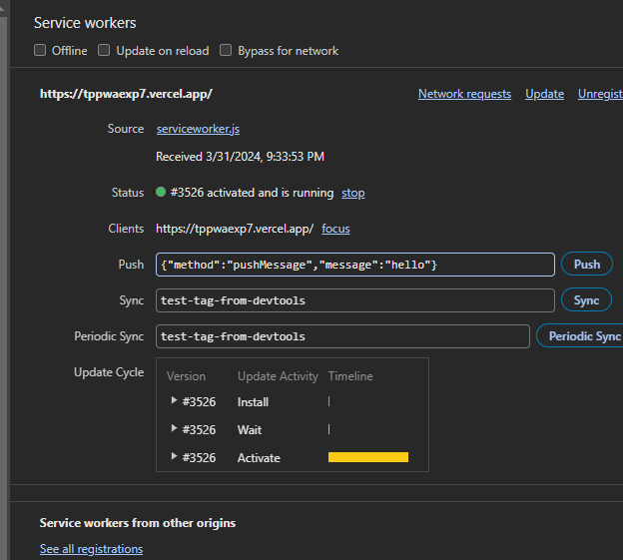

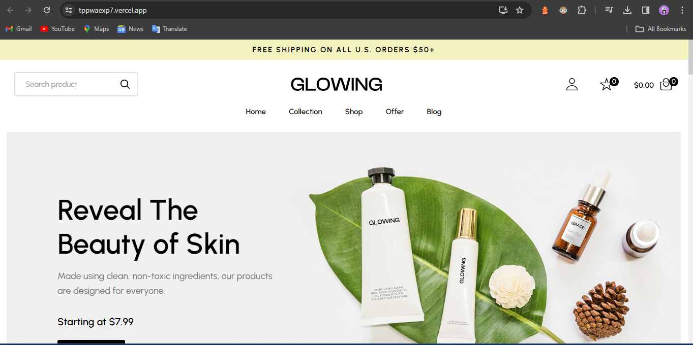

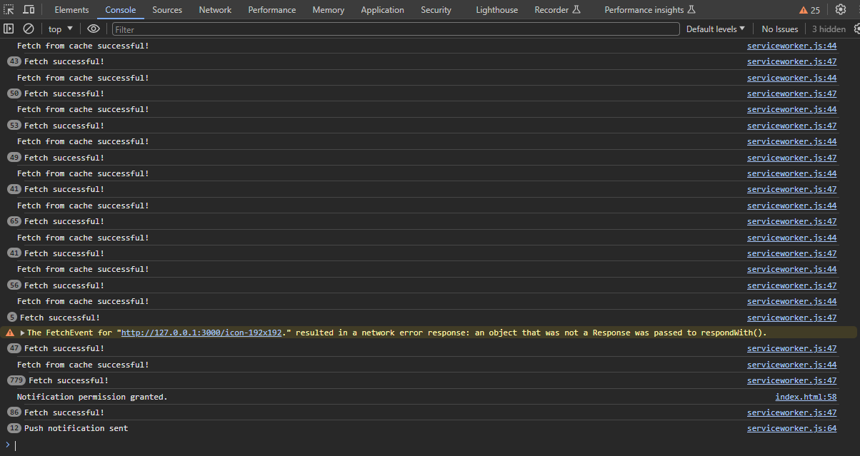

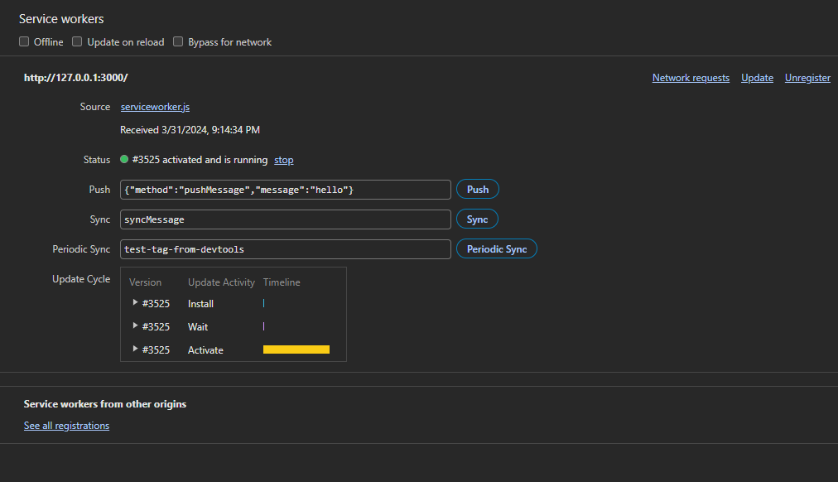

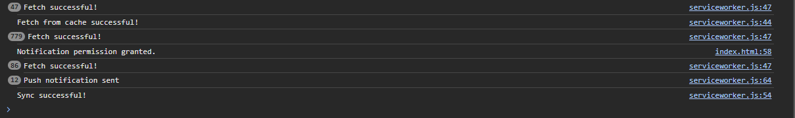

Conclusion -

In this experiment, we have successfully implemented service worker events like fetch, sync and push for E-commerce PWA and found out output for above implementation.

MAD & PWA Lab

Journal

| Experiment No. | 10 |
| --- | --- |
| Experiment Title. | To study and implement deployment of Ecommerce PWA to GitHub Pages. |
| Roll No. | 49 |
| Name | Gaurang A Roarane |
| Class | D15A |
| Subject | MAD & PWA Lab |
| Lab Outcome | LO5: Design and Develop a responsive User Interface by applying PWA Design techniques |
| Grade: | 15 |

Experiment - 10

**Aim -** To study and implement deployment of Ecommerce PWA to GitHub Pages

**Theory -**

GitHub Pages and Firebase are both excellent platforms for hosting websites and web applications, each with its own set of features, advantages, and limitations. Here's a comparison of the two:

GitHub Pages:

Pros:

1. Familiar interface for GitHub users.

2. Easy setup process.

3. Supports Jekyll for blogging out of the box.

4. Allows custom domains.

Cons:

1. Website code is public unless using a private repository.

2. No HTTPS support for custom domains (currently).

3. Limited plugin support for Jekyll.

Firebase:

Pros:

1. Hosted by Google, ensuring reliability and scalability.

2. Offers authentication, cloud messaging, and other useful services.

3. Provides a real-time database and blob store.

4. HTTPS support with free SSL certificate provisioned for custom domains.

Cons:

1. Limited to 10 GB of data transfer per month.

2. Command-line interface only.

Reasons to Choose GitHub Pages:

1. Free to use and integrates seamlessly with GitHub repositories.

2. Easy setup process, particularly for static websites.

3. Great for hosting blogs with Jekyll.

4. Supports custom domains.

Reasons to Choose Firebase:

1. Real-time backend capabilities make it suitable for dynamic and collaborative applications.

2. Provides a broader range of services beyond hosting, such as authentication and cloud messaging.

3. HTTPS support and free SSL certificates for custom domains.

4. Hosted by Google, ensuring reliability and scalability.

In summary, GitHub Pages is a great choice for static websites, particularly for users already familiar with GitHub, while Firebase offers a more comprehensive platform for building dynamic and real-time applications with additional backend services. Your choice should depend on the specific needs and requirements of your project.

**Screenshot -**

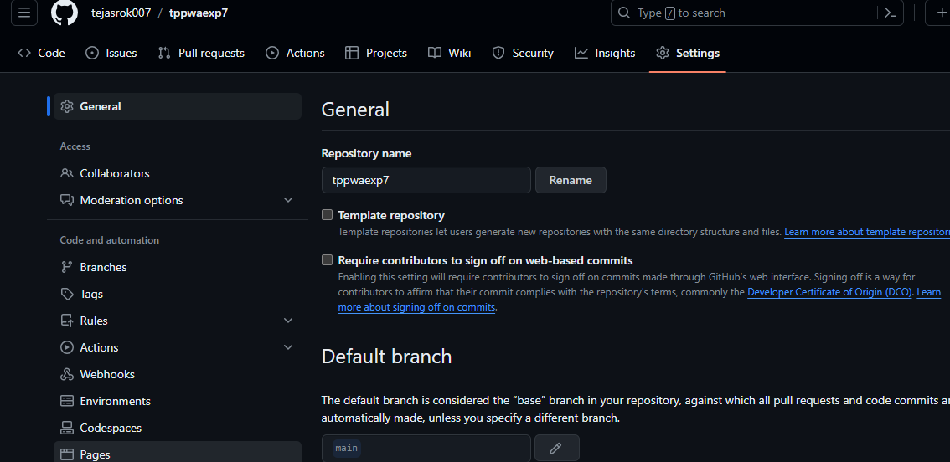

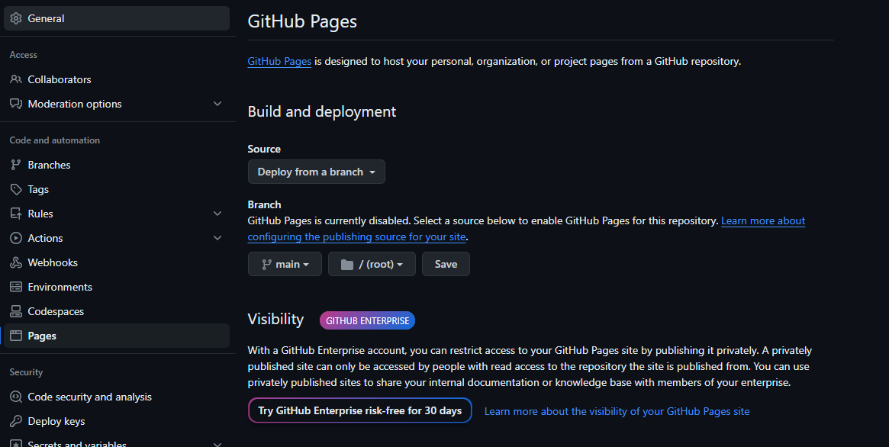

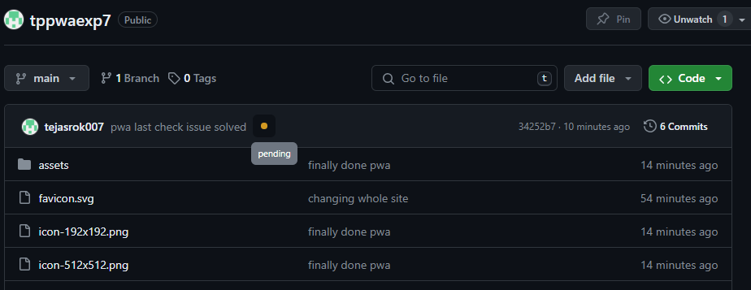

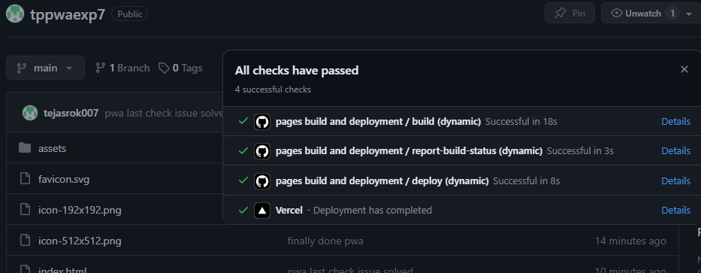

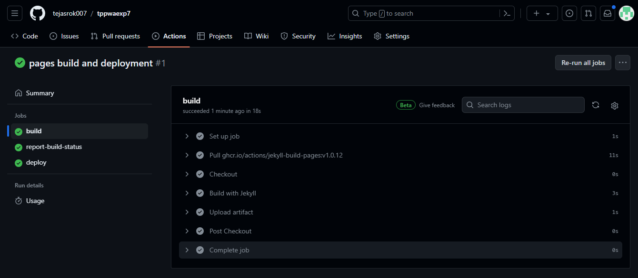

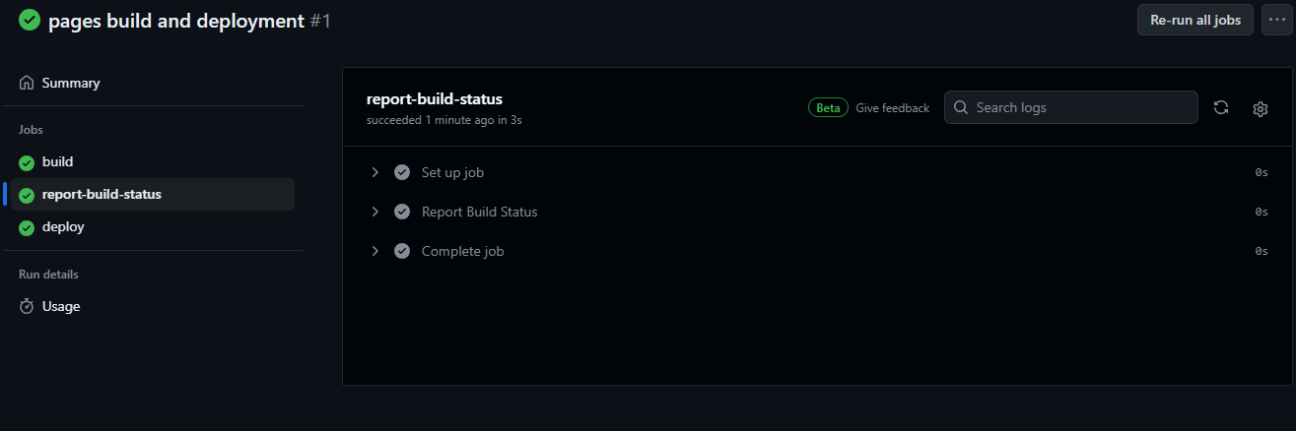

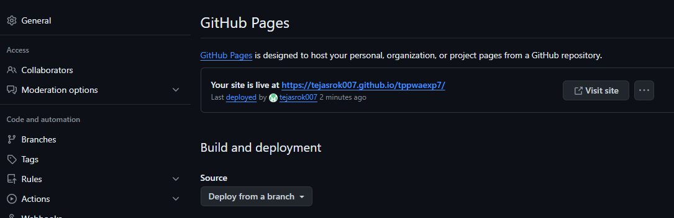

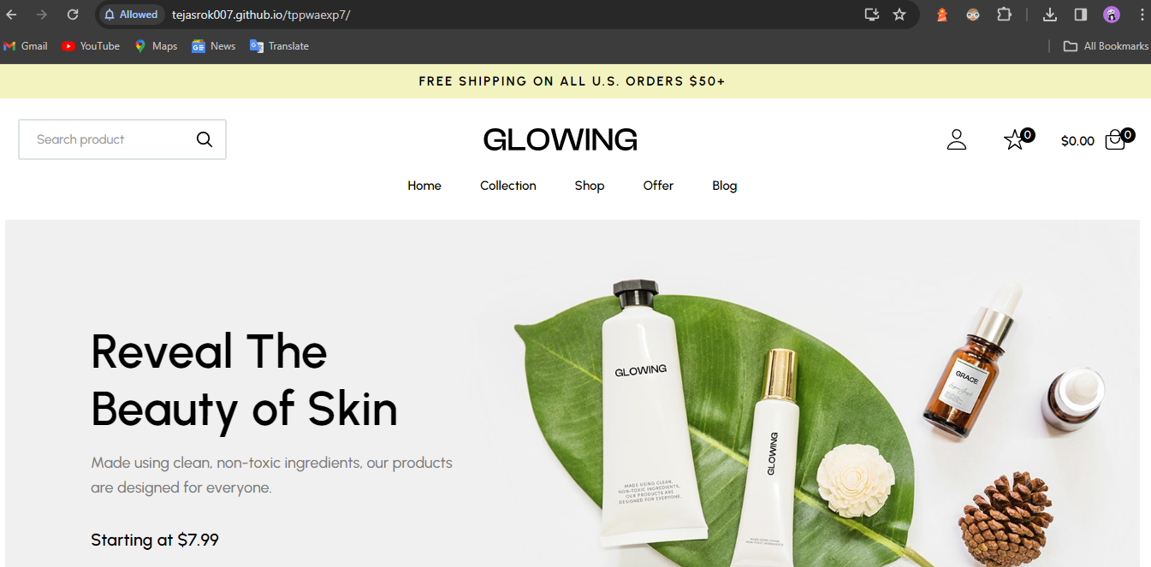

Github - <https://tejasrok007.github.io/tppwaexp7/>

Conclusion -

In this experiment, we have registered a service worker, and completed the install and activation process for a new service worker for the E-commerce PWA.

MAD & PWA Lab

Journal

| Experiment No. | 11 |
| --- | --- |
| Experiment Title. | To use google Lighthouse PWA Analysis Tool to test the PWA functioning. |
| Roll No. | 49 |
| Name | Gaurang A Roarane |
| Class | D15A |
| Subject | MAD & PWA Lab |
| Lab Outcome | LO6: Develop and Analyze PWA Features and deploy it over app hosting solution |
| Grade: | 15 |

Experiment - 11

**Aim -** To use google Lighthouse PWA Analysis Tool to test the PWA functioning.

**Theory -**

Google Lighthouse is a powerful open-source tool designed to improve the quality of web pages by providing comprehensive audits across various metrics. Here's a breakdown of its features:

1. Performance:

- Provides valuable metrics to optimize site performance, including opportunities for improvement.

- Offers insights into render-blocking resources such as stylesheets, scripts, and HTML imports.

- Combines data from both real-world usage (Field Data) and simulated conditions (Lab Data) for a comprehensive analysis.

2. Accessibility:

- Highlights potential improvements to enhance accessibility and user experience.

- Ensures that websites are easily navigable and usable for all users, including those with disabilities.

- Improving accessibility can also positively impact search engine rankings.

3. Best Practices:

- Offers recommendations to improve overall site performance and user experience, particularly for mobile sites.

- Provides suggestions for adhering to best practices in web development and design.

4. SEO:

- Evaluates a website's optimization for search engine rankings.

- Provides essential tools to analyze and improve a page's visibility in search engine results.

- Covers fundamental aspects of SEO, though not all factors may be considered.

5. Progressive Web Applications (PWAs):

- Assess whether a website meets the criteria for being classified as a Progressive Web App.

- Focuses on key factors such as service worker registration, enabling push notifications, and offline capabilities.

- Helps developers enhance the user experience and engagement with modern web app features.

Overall, Google Lighthouse offers a comprehensive suite of metrics and recommendations to help developers optimize their websites for performance, accessibility, SEO, and PWA features. By addressing the issues identified in the Lighthouse report, developers can improve their site's user experience, search engine visibility, and overall quality.

{

"name":"PWA Tutorial",

"short_name":"PWA",

"start_url":"index.html",

"display":"standalone",

"background_color":"#5900b3",

"theme_color":"black",

"scope": ".",

"description":"This is a PWA tutorial.",

"icons":[

{

"src":"icon-192x192.png",

"sizes":"192x192",

"type":"image/png",

"purpose":"any maskable"

},

{

"src":"icon-512x512.png",

"sizes":"512x512",

"type":"image/png",

"purpose":"any maskable"

}

]

}

**ScreenShot -**



















**Conclusion -**

In this experiment, we have successfully used Google Lighthouse PWA Analysis Tool for testing the PWA functioning.

MAD & PWA Lab

Journal

| Experiment No. | Assignment-1 |
| --- | --- |
| Assignment 1 Questions | 1. Flutter Overview:Explain the key features and advantages of using Flutter for mobile app development. Discuss how the Flutter framework differs from traditional approaches and why it has gained popularity in the developer community.  2. Widget Tree and Composition: Describe the concept of the widget tree in Flutter. Explain how widget composition is used to build complex user interfaces. Provide examples of commonly used widgets and their roles in creating a widget tree.  3. State Management in Flutter: Discuss the importance of state management in Flutter applications. Compare and contrast the different state management approaches available in Flutter, such as setState, Provider, and Riverpod. Provide scenarios where each approach is suitable.  4. Firebase Integration in Flutter: Explain the process of integrating Firebase with a Flutter application. Discuss the benefits of using Firebase as a backend solution. Highlight the Firebase services commonly used in Flutter development and provide a brief overview of how data synchronization is achieved. |
| Roll No. | 49 |
| Name | Gaurang A Roarane |
| Class | D15A |
| Subject | MAD & PWA Lab |
| Lab Outcome | LO1: Understand cross platform mobile application development using Flutter framework  LO2: Design and Develop interactive Flutter App by using widgets, layouts, gestures and animation  LO3: Analyze and Build production ready Flutter App by incorporating backend services and deploying on Android / iOS |
| Grade: |  |

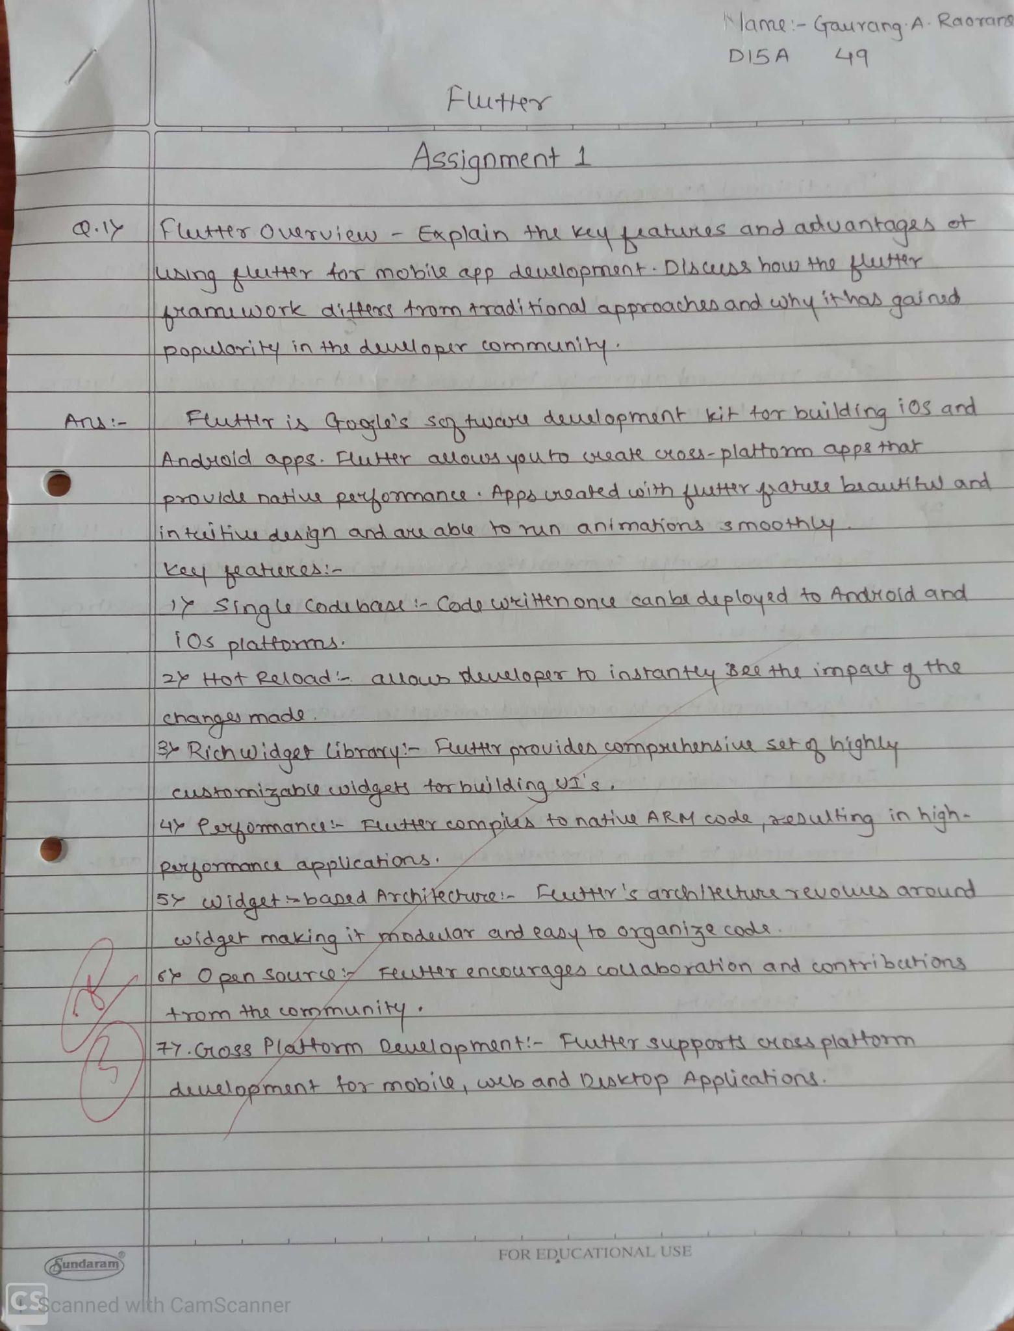

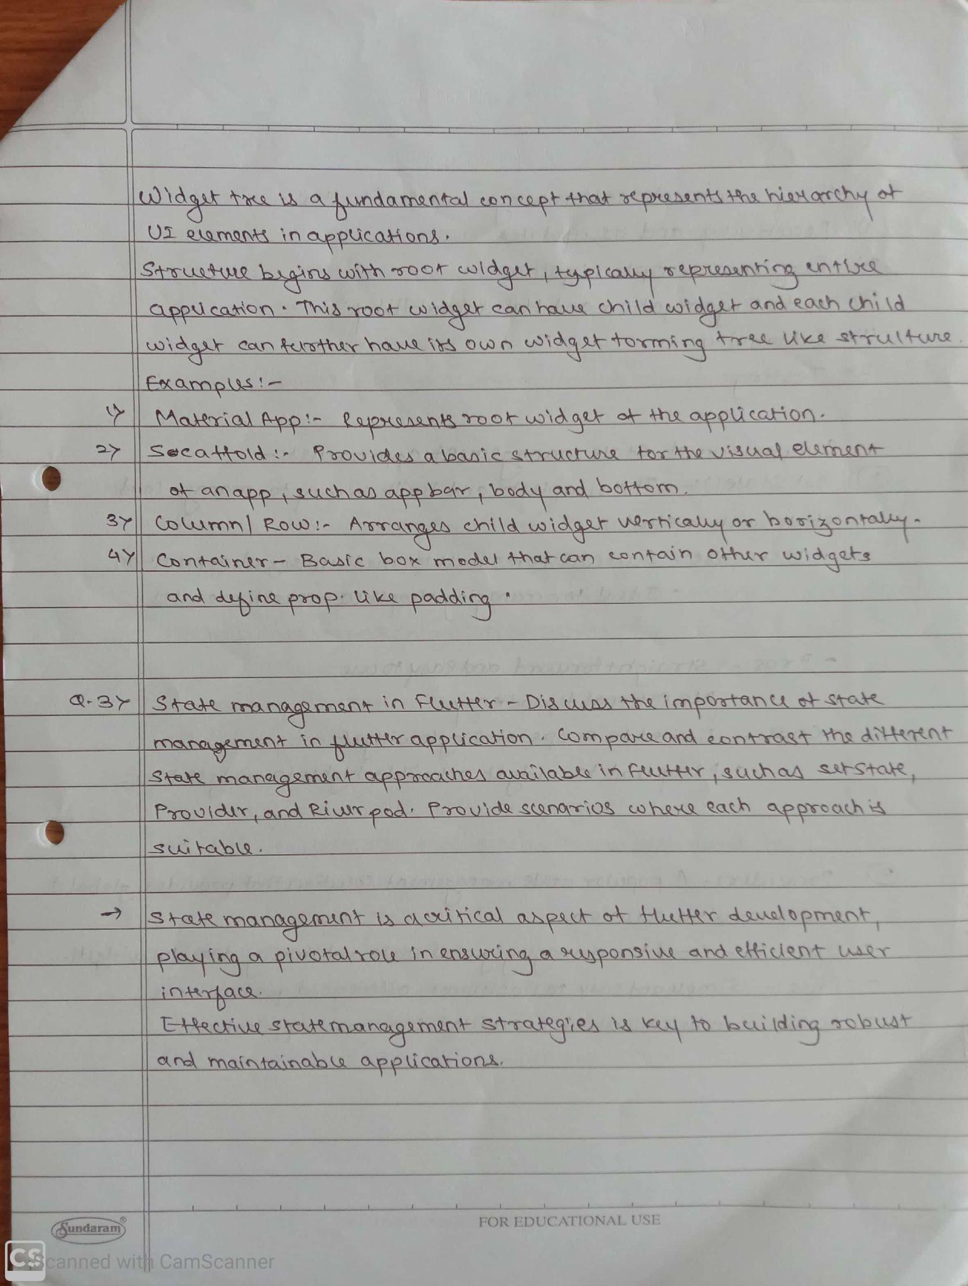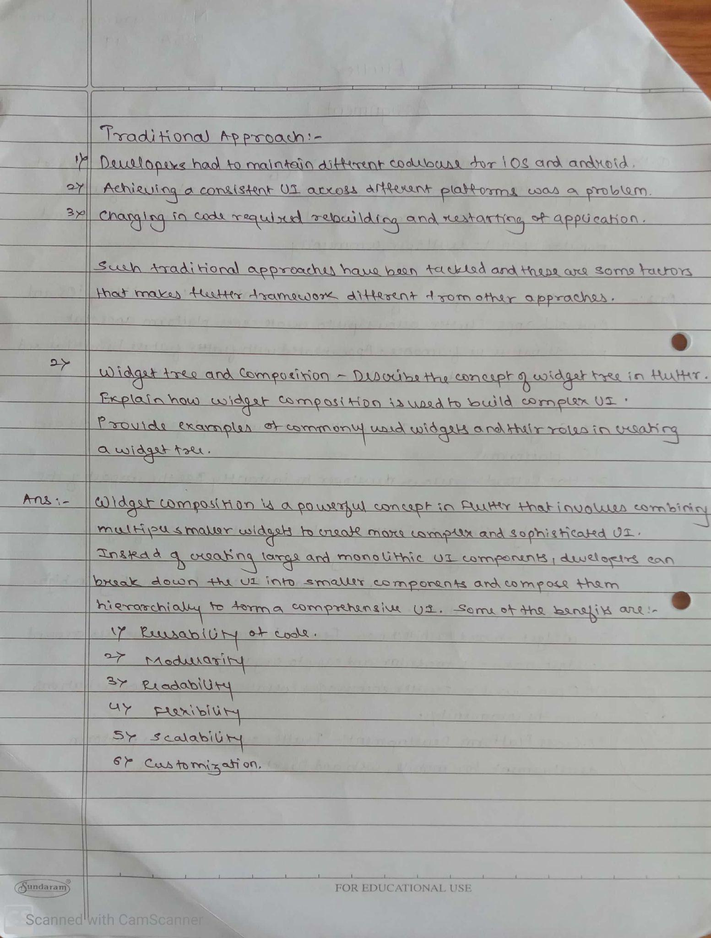

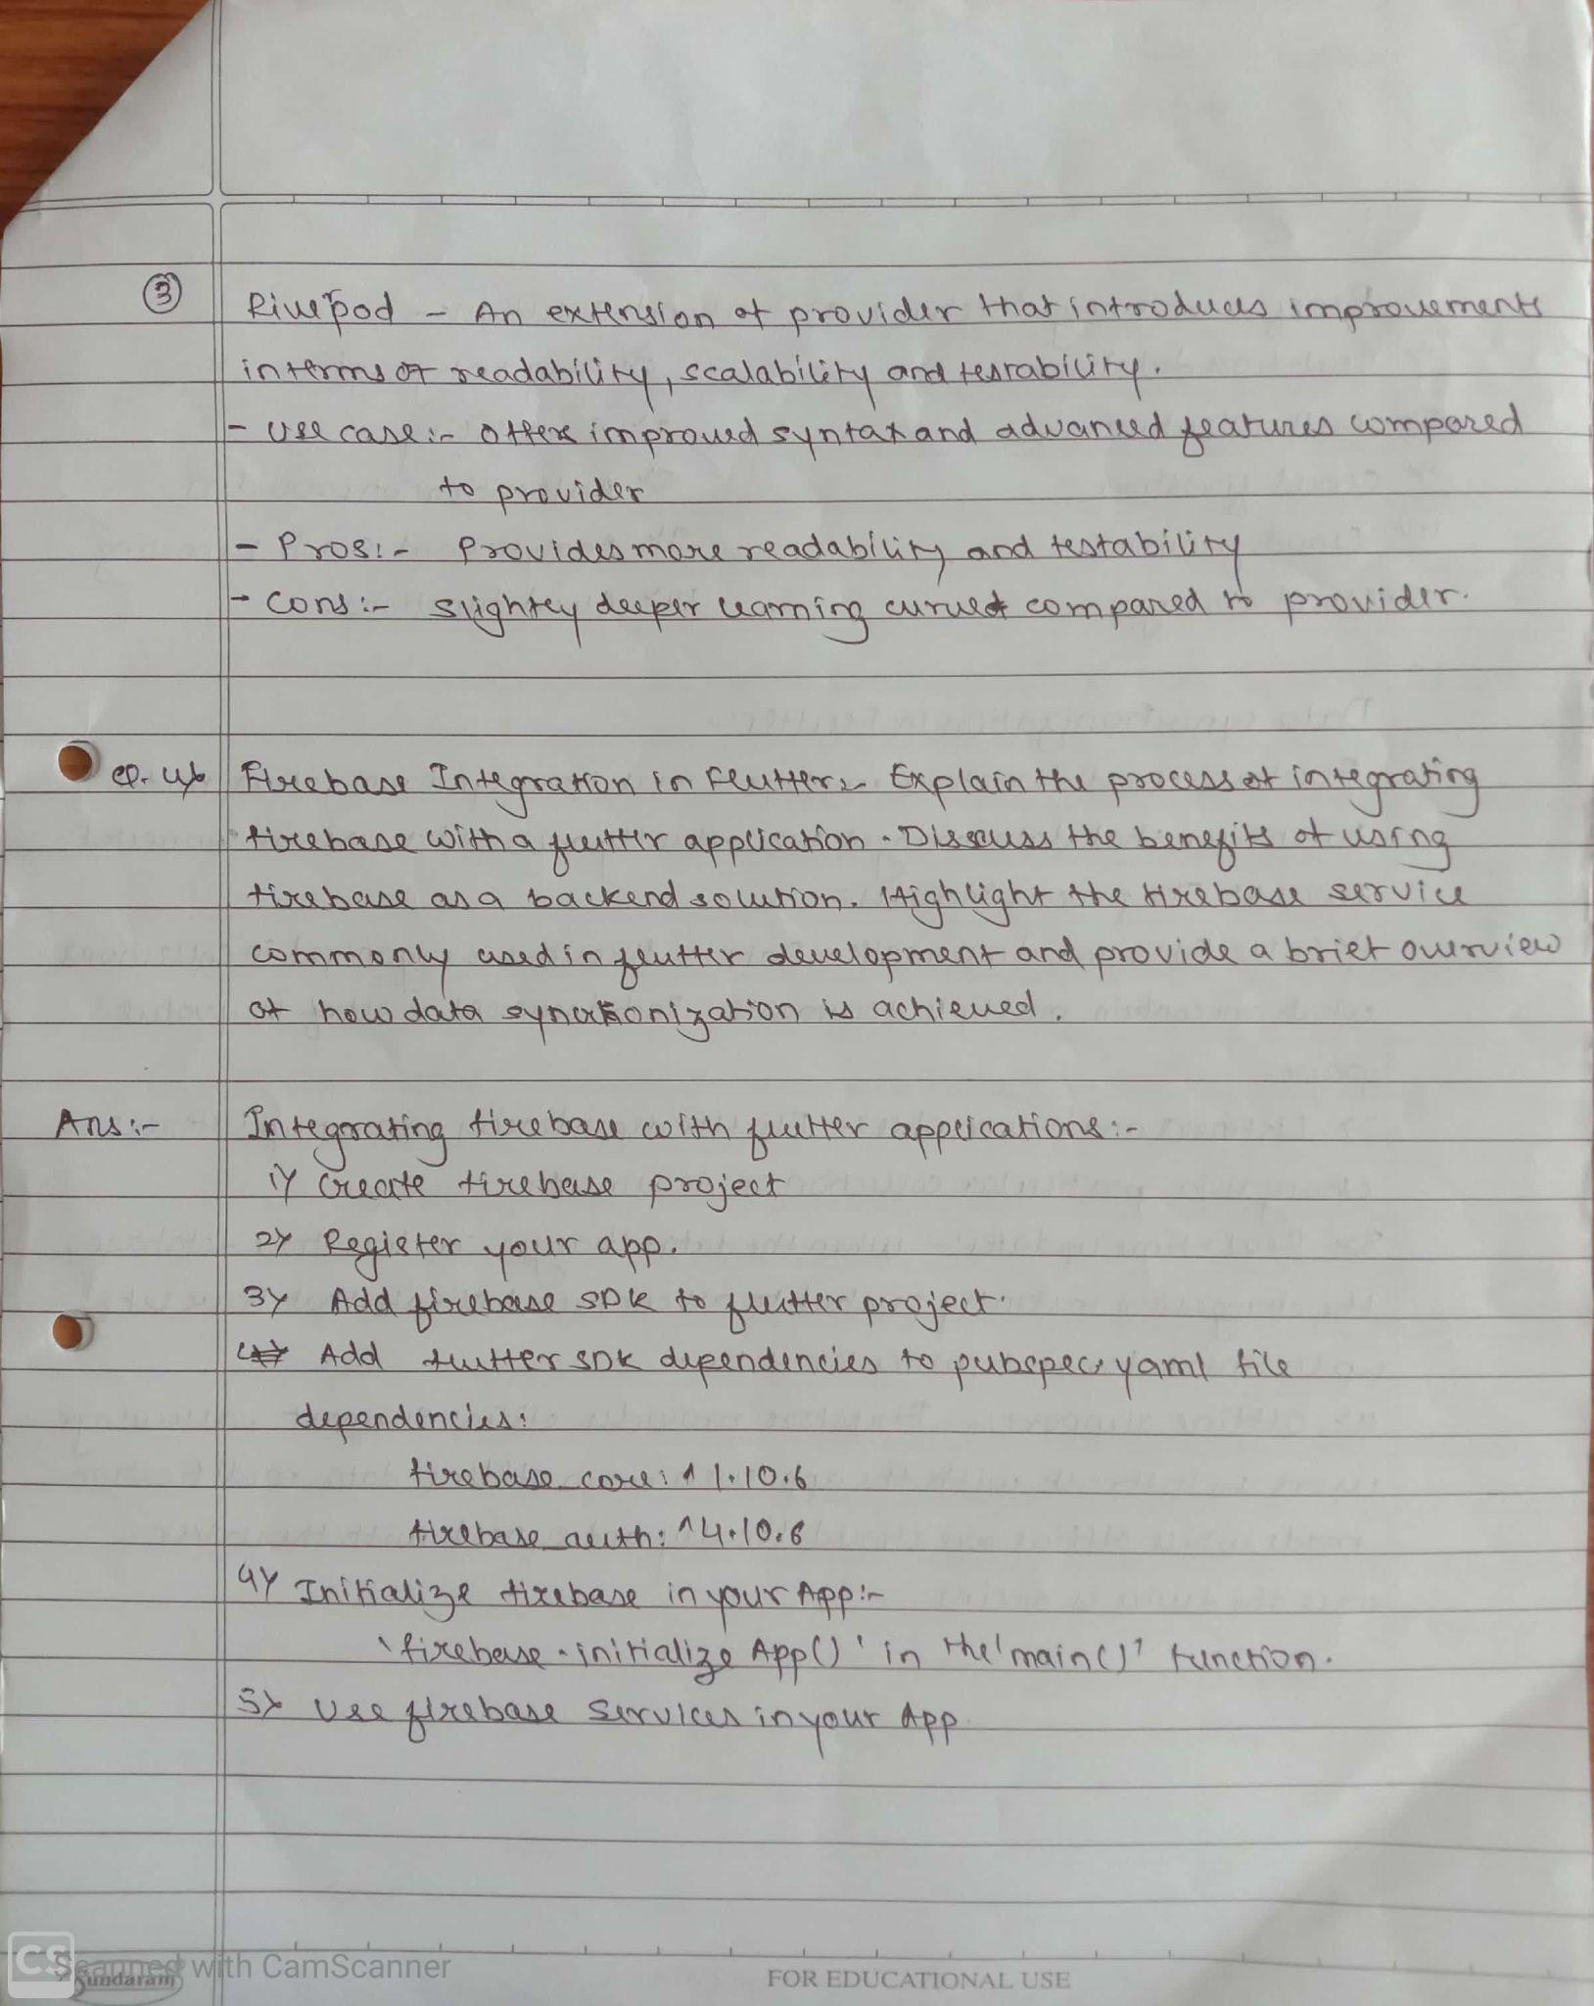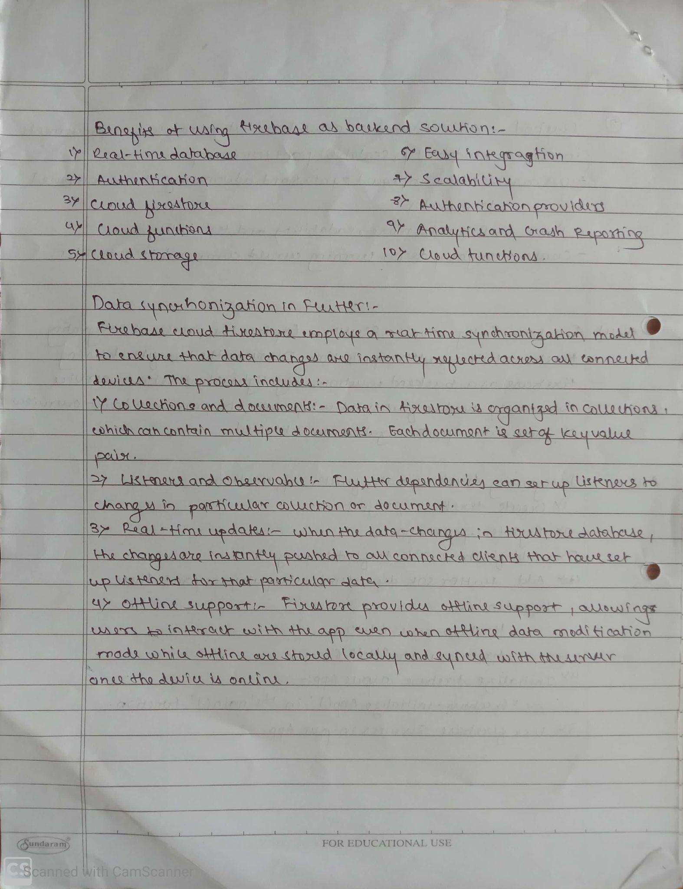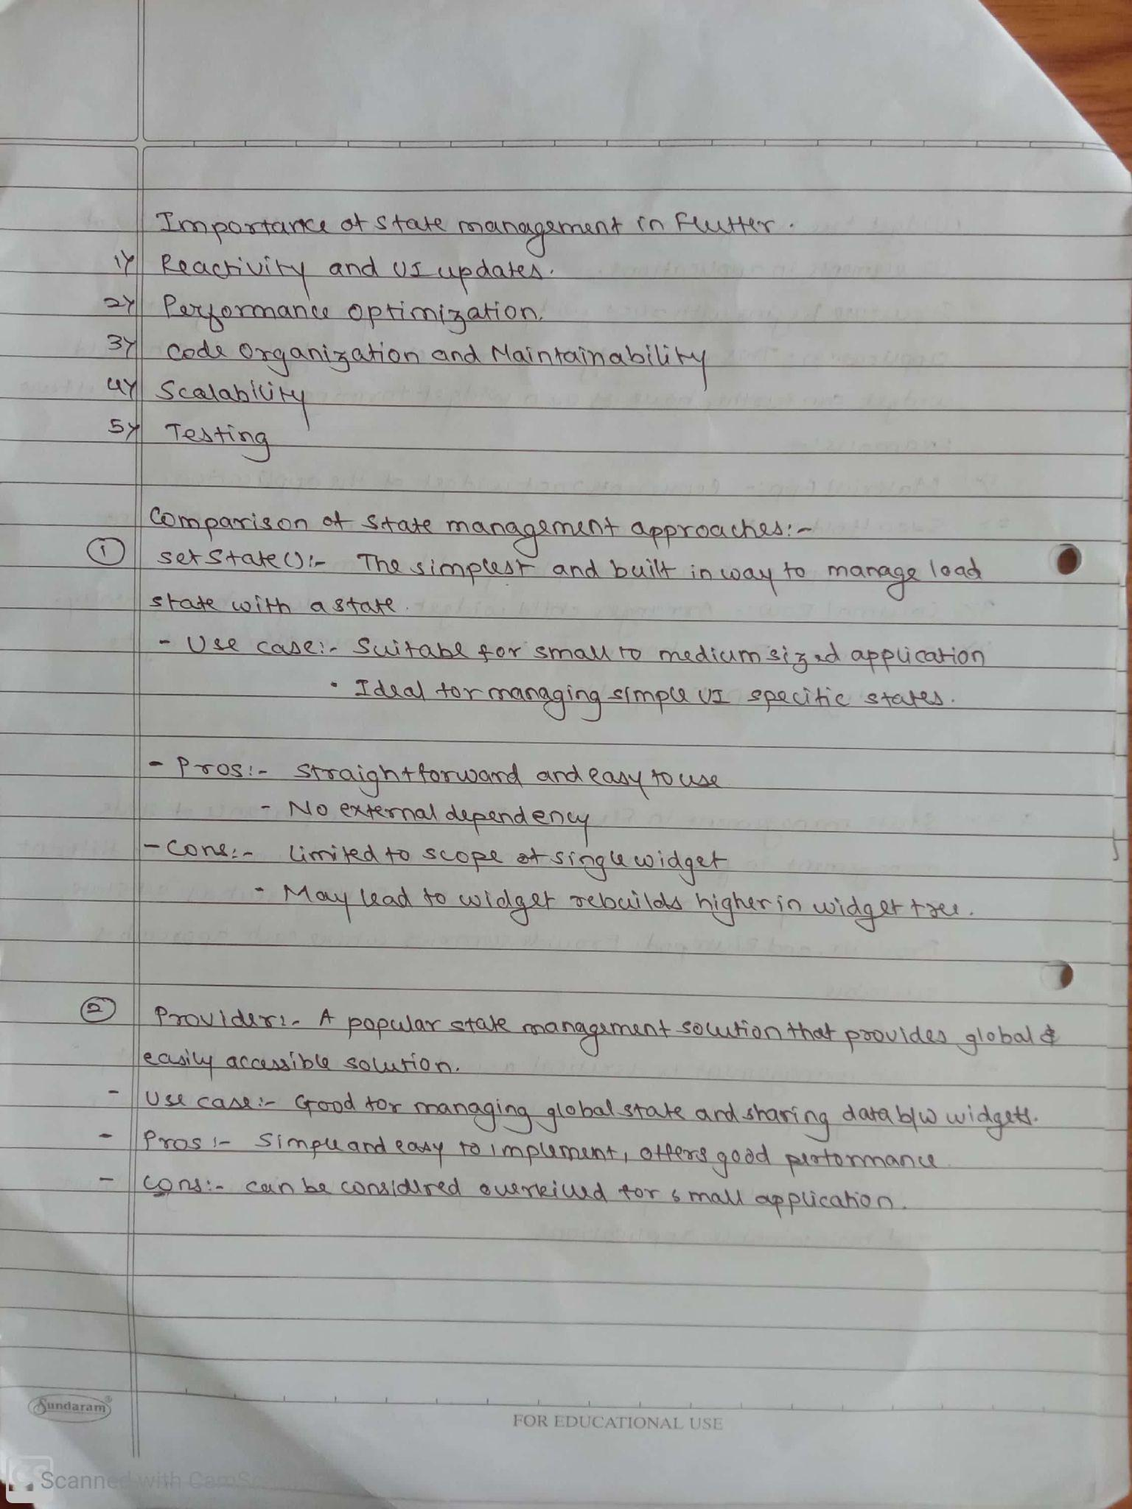

MAD & PWA Lab

Journal

| Experiment No. | Assignment-2 |
| --- | --- |
| Assignment 2 Questions | 1. Define Progressive Web App (PWA) and explain its significance in modern web development.Discuss the key characteristics that differentiate PWAs from traditional mobile apps 2. Define responsive web design and explain its importance in the context of Progressive Web Apps.Compare and contrast responsive, fluid, and adaptive web design approaches. 3. Describe the lifecycle of Service Workers, including registration, installation, and activation phases. 4. Explain the use of IndexedDB in the Service Worker for data storage. |
| Roll No. | 49 |
| Name | Gaurang A Roarane |
| Class | D15A |
| Subject | MAD & PWA Lab |
| Lab Outcome | LO4:Understand various PWA frameworks and their requirements  LO5: Design and Develop a responsive User Interface by applying PWA Design techniques  LO6:Develop and Analyze PWA Features and deploy it over app hosting solutions |
| Grade: |  |

